The Bible Speaks
Racial Unity – Part 2

- Review – Critical Race Theory

- A Human and Historical Perspective

- A Biblical View

The Bible Speaks
Racial Unity – Part 2

Discussion:
- When you consider the countless historical examples of “man’s inhumanity to man”, do you think there is something inside us that inevitably divides into “us” and “them”? Can you recall examples in your life?
- What do you think of this statement, “Unity comes about in any group when its members are jointly committed to something greater than themselves and their individual interests” True or false?
- In Ephesians 2:19-22, we see that the unity that Jesus brought transcends ‘membership’. The Bible sees it as joining God’s family. How is this ‘adoption’ idea an even more powerful form of unity?
- Ephesians 4:1 sums up the discussion on unity by urging us to “live a life worthy of our calling”. What are some ways this will create and maintain unity among Christ-followers?

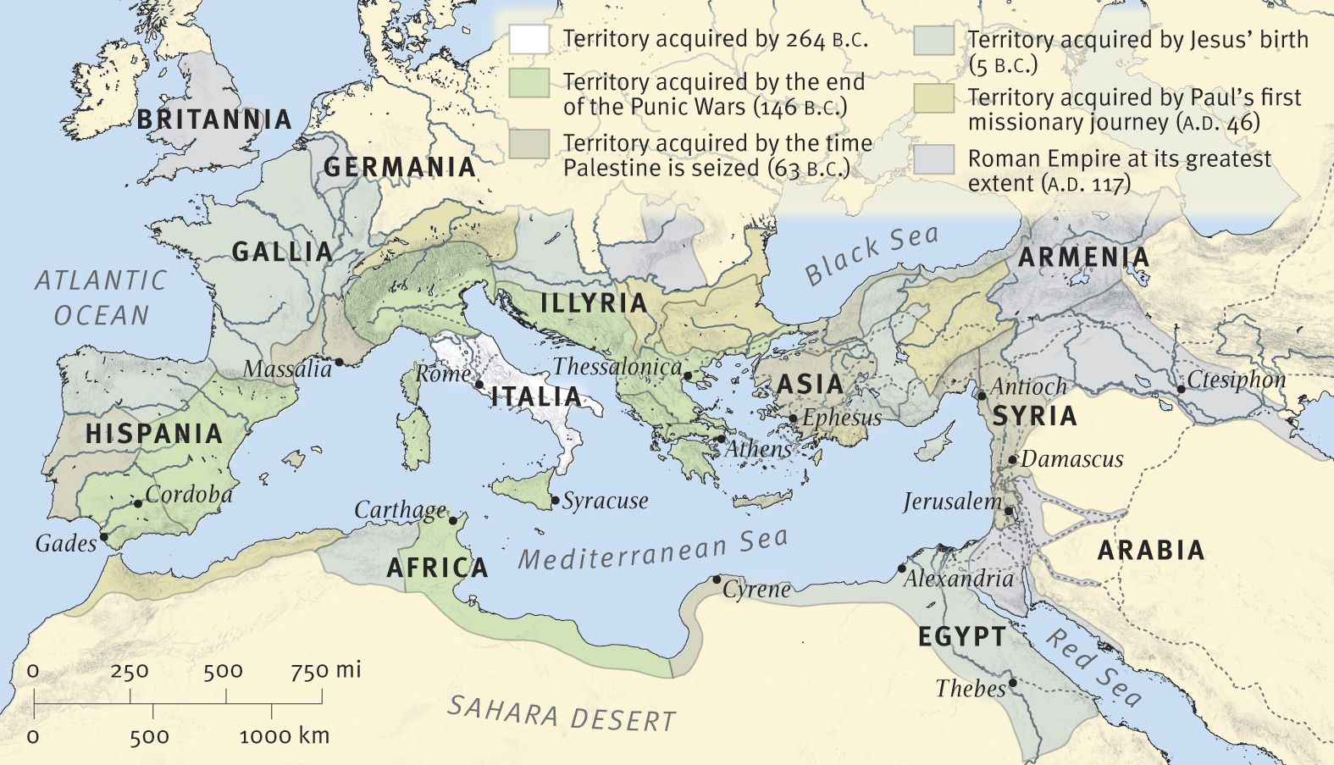
The Roman World at the time of the New Testament

