Moses, Muhammad, and Marx
Religions Shaping the Modern World

- Introduction – Modern Belief Systems

- Moses - Judaism

- Muhammad – Islam

- Marx – Modern Secular Religion

- The Christian Story

Moses, Muhammad, and Marx
Religions Shaping the Modern World

Discussion:
- Growing up, what would you say was the story that guided your understanding of the world?
- Do you think that some stories (also often known as “theories”) are true, independent of our beliefs and feelings about them?
- What are some implications of the Christian story? About people, truth, morality, conduct?
- What effect does the existence of heaven and hell have on our concept of justice?

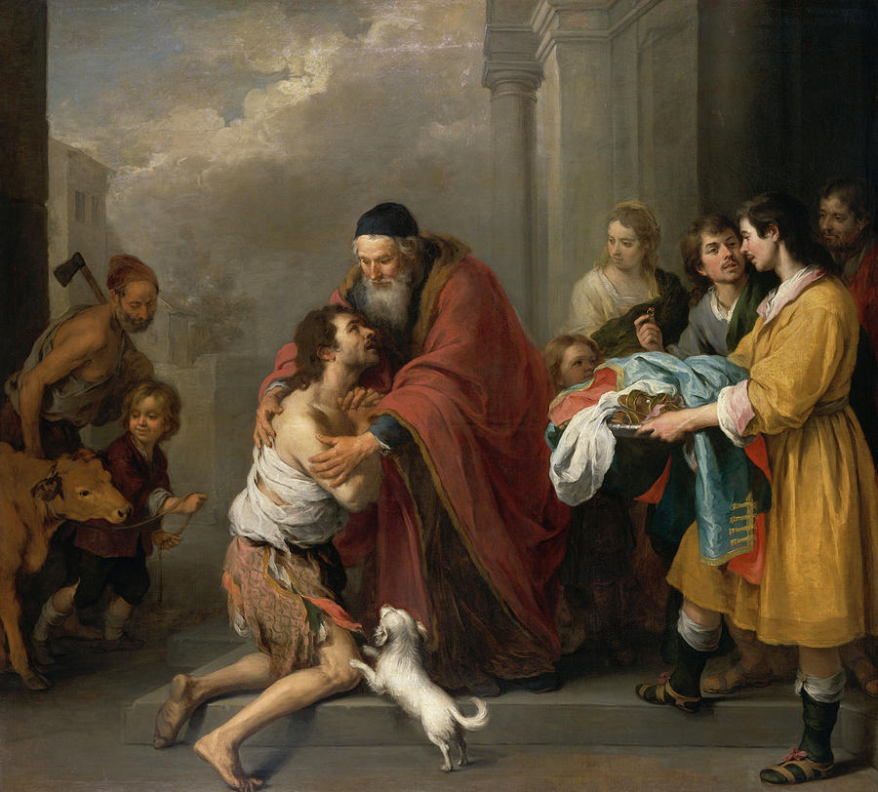
The Return of the Prodigal Son, Murillo 1670

