The Bible Speaks: Politics
Part 2 – Culture and Politics

- Recap: “Playing a Different Game”

- Politics is Downstream from Culture

- Christians and the Culture

- Takeaways:

The Bible Speaks: Politics
Part 2 – Culture and Politics

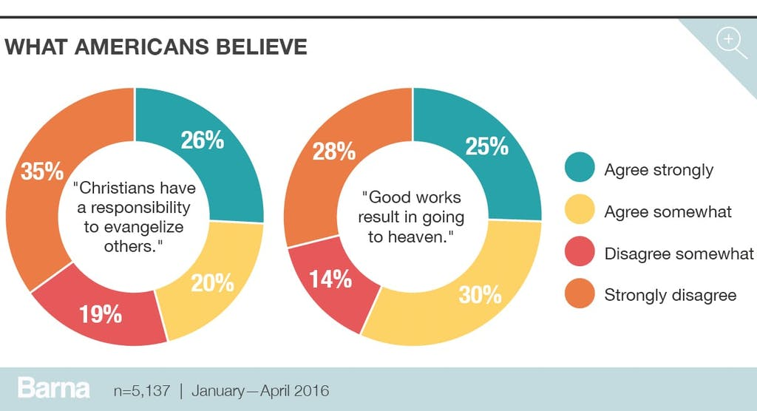

Discussion:
- What are some implications of Jesus’ statement that his followers would be yeast or salt in society?
- Why do you think Christian beliefs do not always translate into significant behavioral change? (Consider the Parable of the Sower in Matthew 13:1-23)
- Discuss the implications of the Mother Theresa quote, “God does not demand that I be successful. God demands that I be faithful.”

