The Bible Speaks: Politics
Part 7 – The Spirit of Politics

- Summary:
  - Different Game, Different Aim

- “Where does my help come from?”

  - Is Jesus sufficient?

- Re-Minding

- What to do with your anxieties about the future?

The Bible Speaks: Politics
Part 7 – The Spirit of Politics

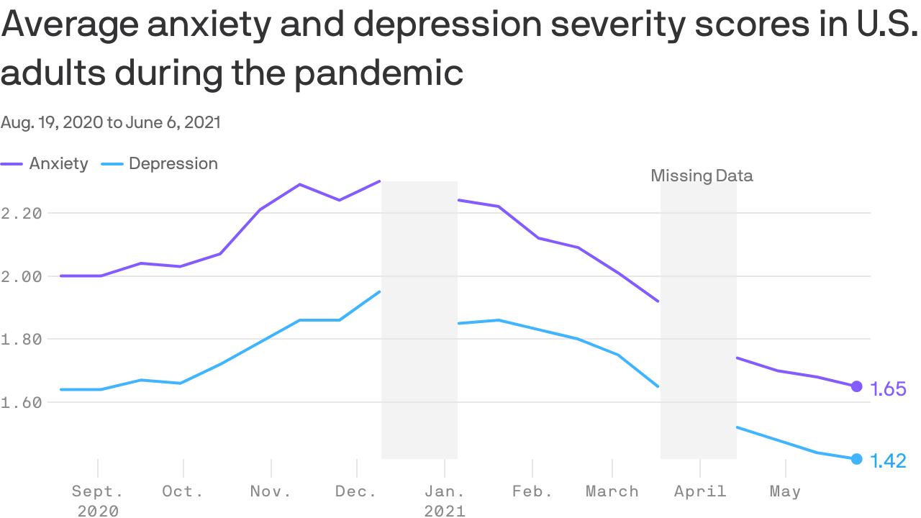
Source: CDC

Discussion:
- Which characteristic of the fruit of the Spirit (Galatians 5:22) is most elusive for you?
- What are some ways you can re-mind yourself when you feel anxious, angry, etc.?
- What role does prayer play in your cultivation of the fruit of the Spirit? Share your ideas and experiences.

