The Bible Speaks: Politics
Part 5 – A Different Game: Living by the Spirit

- Summary:
  - Different Game
  - Different Goals
  - Our Mission is not Reliant on a Government
  - Transformation vs. Coercion
  - Subversive: Undermining vs. Overwhelming

- A Case Study From 538 B.C.

- Living by the Spirit

- Takeaways

The Bible Speaks: Politics
Part 5 – A Different Game: Living by the Spirit

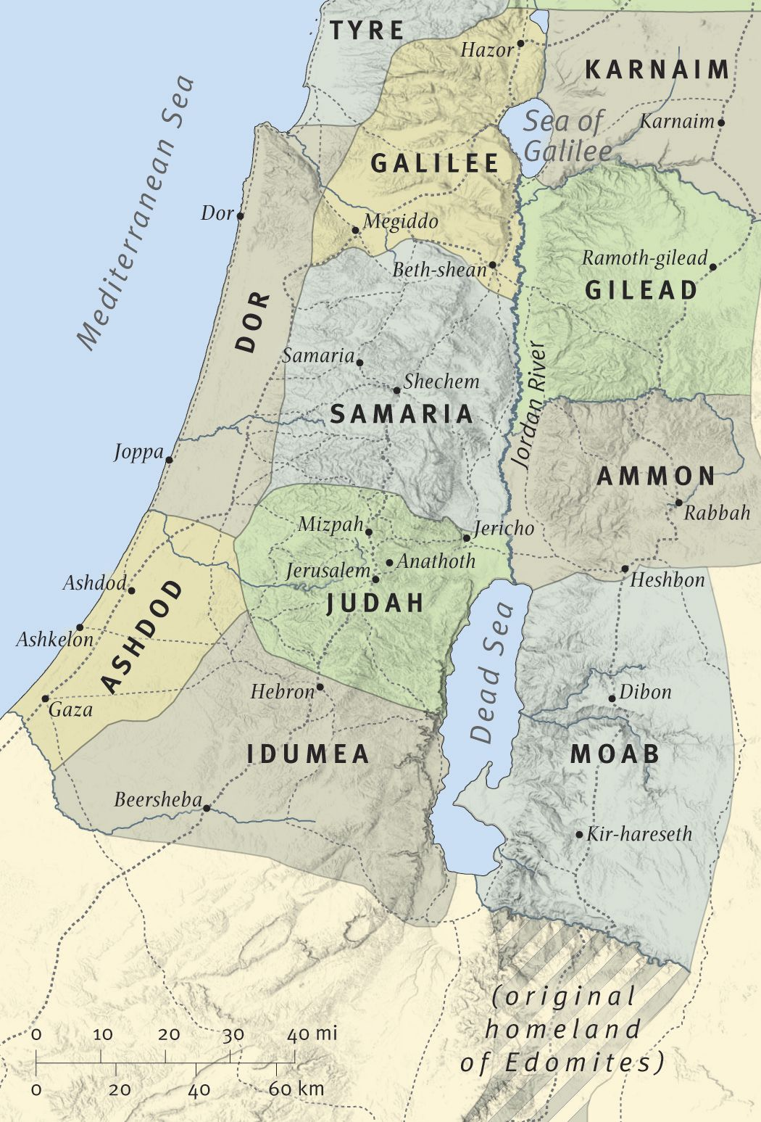
The Land of Israel around 538 B.C. When Zerubbabel and the 1st Group of Israelite Exiles Returned

Discussion:
- What are your takeaways from the story of God’s rebuilding of Israel during the time of Zerubbabel and the Israelite return from exile?
- Does the character of citizens determine the nature of government or vice versa? Why do you think so?
- Discuss what it means for you, in your Monday through Friday life, to live by the Spirit? What are some examples you would share?

