The Bible Speaks: Politics
Part 4 – God and Government

- Recap: “Playing a Different Game, in a Different Way”

- What is a Legitimate Government? Romans 13

- God and Illegitimate Governments

- Takeaways

The Bible Speaks: Politics
Part 4 – God and Government

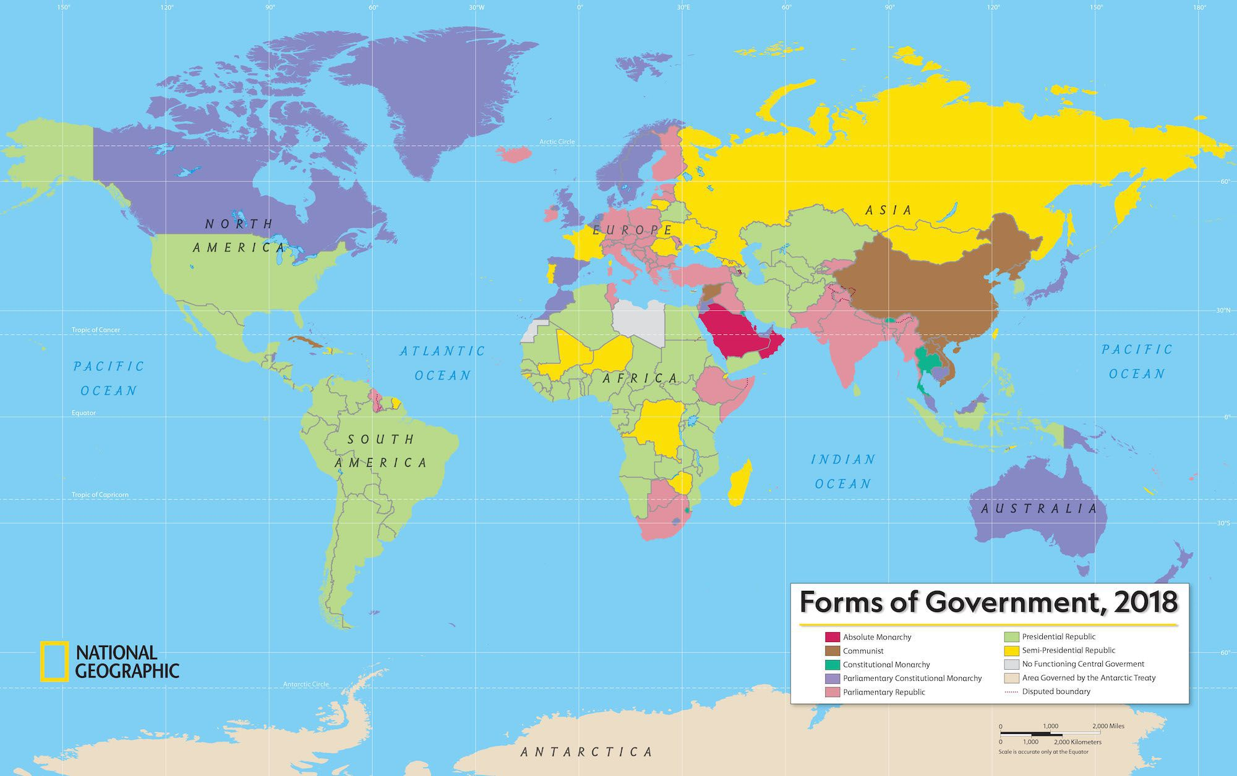

Discussion:
- What are some characteristics of a Biblical government?
- Do you think the type of government or the people in government have the biggest impact on whether a government is legitimate?
- Does it comfort you or concern you that God bends the intentions of illegitimate governments and rulers to his purposes?
- How does God’s ultimate sovereignty affect the way you see politics?

