The Bible Speaks: Politics
Part 1 – Separation of Church and State

- History of “Separation of Church and State”

- “Give to Caesar what is Caesar’s” – Matthew 22

- Takeaways:

The Bible Speaks: Politics
Part 1 – Separation of Church and State

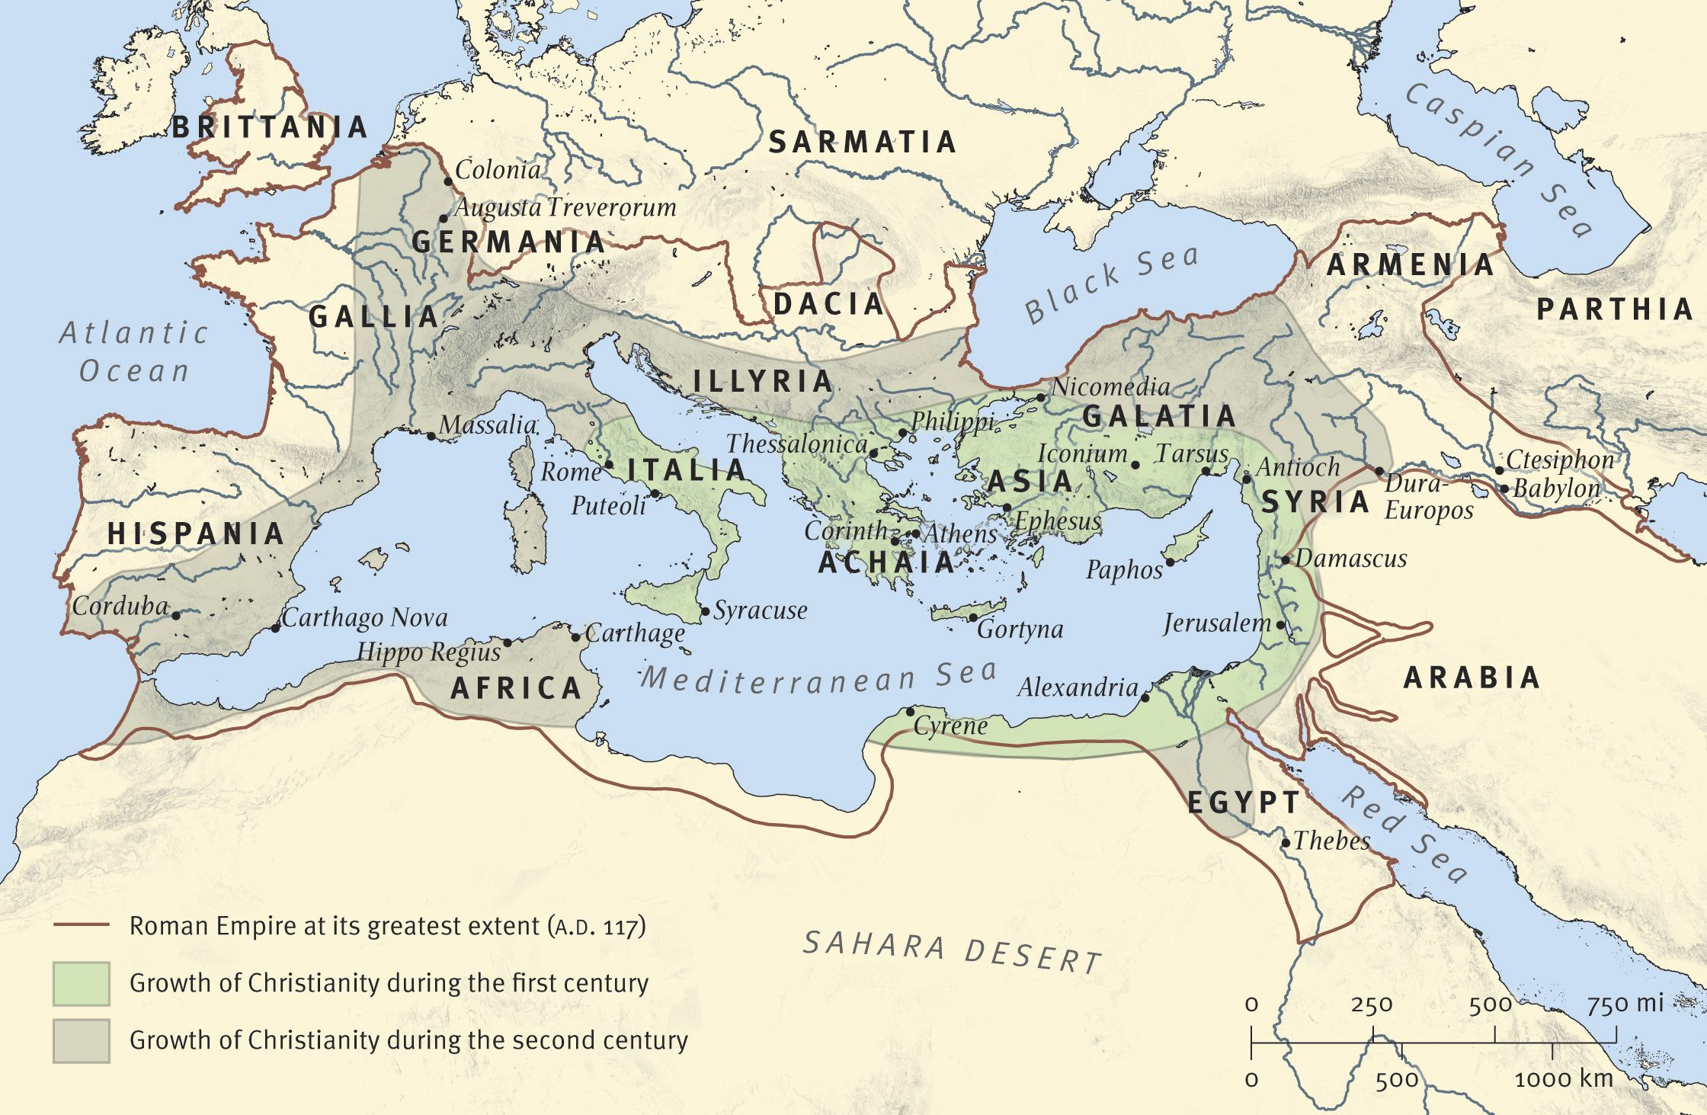
The spread of Christianity within the Roman Empire amidst political persecution in the 1st and 2nd centuries A.D.

Discussion:
- In Matthew 28:18-20, Jesus gave the church its mission, often called The Great Commission. Do you think political involvement by the church has been helpful or harmful to this mission?
- Since the 1940’s the wall between Church and State has been increasingly interpreted to exclude religion from the public square. Do you think this has been beneficial or harmful to our society as a whole?
- Where do you see the Church and Christians most active in the public arena? Where else would you suggest involvement might be helpful?

