The Story Behind Christmas
Part 2 – The Plan to Stop the Messiah (Christ)

The Corruption of Humanity

The Destruction of Israel

The Plan to Stop the Messiah

The Story Behind Christmas
Part 2 – The Plan to Stop the Messiah (Christ)

For Further Discussion:
- Are you surprised by how long God worked to redeem us? Are you surprised how hard Satan tried to stop it?
- The Jewish people were chosen by God to play a role in his plan of redemption. Despite their frequent unfaithfulness to God, they survived – why do you think that is?
- Why do you think Jesus came into the world as a defenseless baby rather than a conquering warrior?

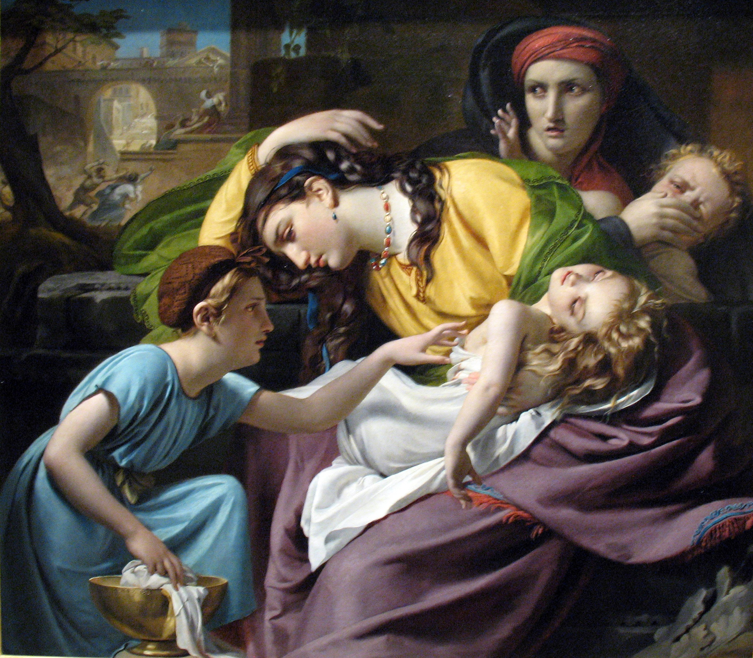
Massacre of the Innocents, Francois-Joseph Navez, 1824

