Stories in the Gospels
John 18:28 – 19:16 Jesus and Pilate

Background : Pontius Pilate

Jesus and Pilate

Lessons:

Stories in the Gospels
John 18:28 – 19:16 Jesus and Pilate

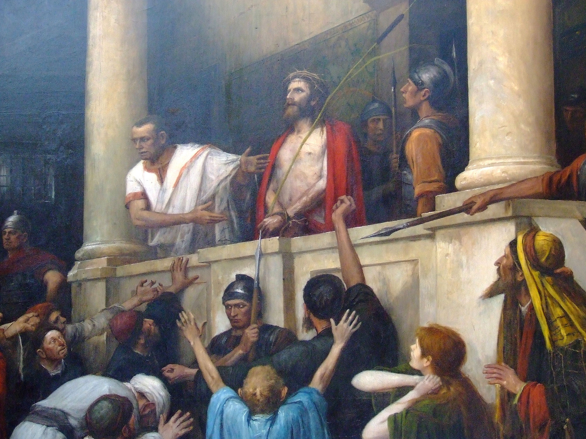
Ecce Homo (“Behold the man”), Mihaly Munkacsv,
1896 A.D.

For Further Discussion:
- When you read this story, what is your immediate emotional reaction? Your mental reaction?
- All four Gospels report the events of Jesus before Pilate. Why do you think this is so important in the story of Jesus? What would change if it were left out?
- Jesus seems very sure of himself on the brink of unimaginable suffering. How could he do this? (Hint: Read Hebrews 12:1-3)
- God worked through the politics and self-interest of 1st century Judea. Do you think he does the same today?

