Stories in the Gospels
John 1 – The Logos

Logos – The Word

Light and Darkness

Children of God

Grace and Truth – Overcoming the World

Stories in the Gospels
John 1 – The Logos

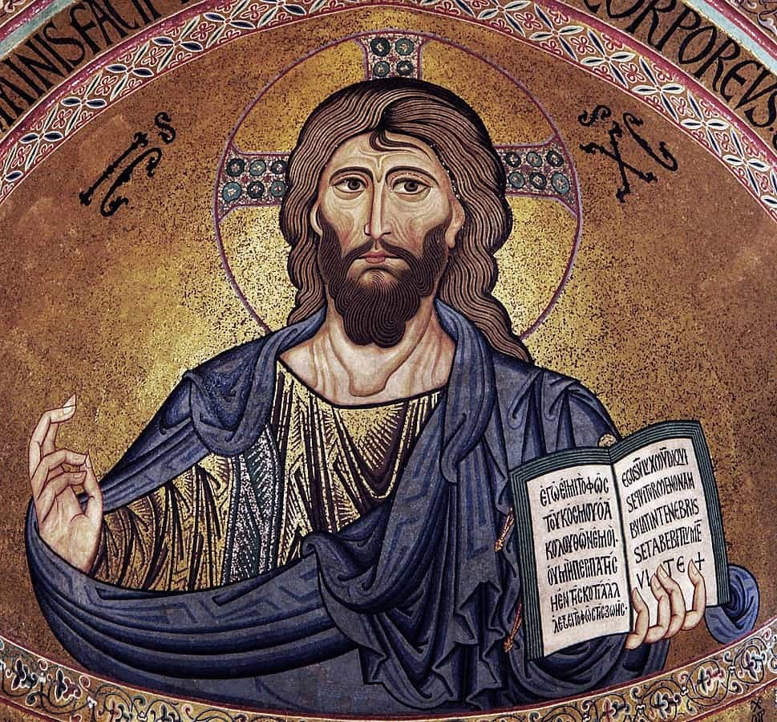
Jesus, The Word of God

For Further Discussion:
- Why do you think the gospel of John begins with such an intentional parallel with Genesis chapter 1?
- The themes of Light-Darkness, Good-Evil, Truth-Falsehood run through the Bible from beginning to end. Where else in our culture do you see these themes?
- How would you answer if you were asked, “Who is Jesus?”

