**Stories in the Gospels**

Luke 5:1-11

Fishing on the Sea of Galilee

“Because you say so”

“Depart from me for I am a sinful man”

**Stories in the Gospels**

Luke 5:1-11

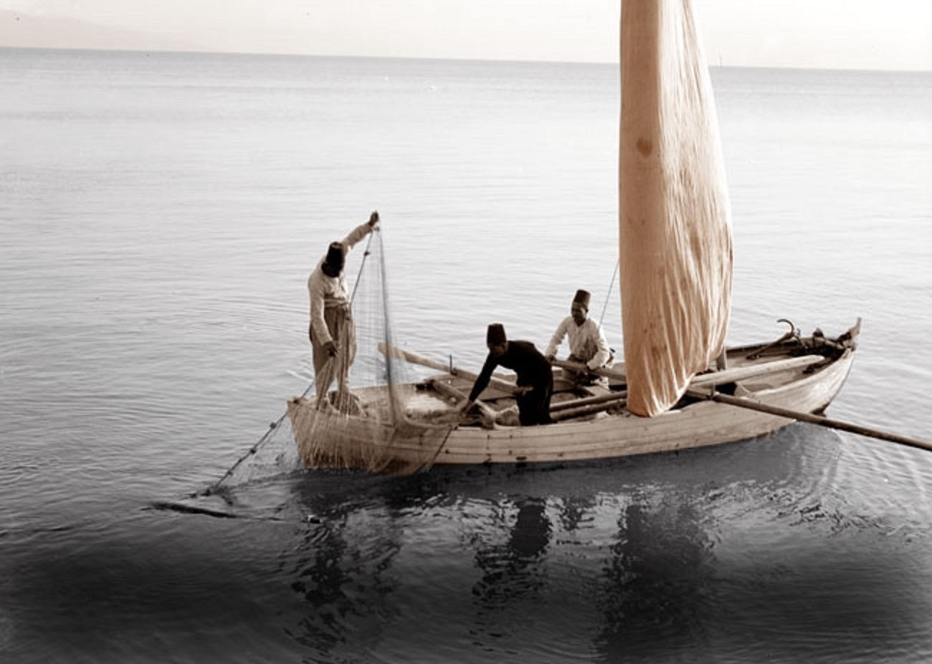

*Fishermen on the Sea of Galilee*

For Further Discussion:

1. If you were Peter what would you have answered when Jesus told you to put out into deep water and let down the nets?
2. If you saw a miracle, would it be easy or difficult to walk away from everything and follow Jesus?
3. Have you had a “because you say so” moment in your life? How did it go?
4. What have you left behind from your life before meeting Jesus?