Stories in the Gospels
Matthew 7:21-23 “Lord, Lord”

The Context and Structure :

(A) Exhortation: The narrow gate (7:13–14)
(B) False prophets: Wolves and bad trees (7:15–20)
(B′) False prophets: “Lord, Lord” (7:21–23)
(A′) Exhortation: House on a rock (7:24–27)

False Teachers

Faith and Obedience

Application

Stories in the Gospels
Matthew 7:21-23 “Lord, Lord”

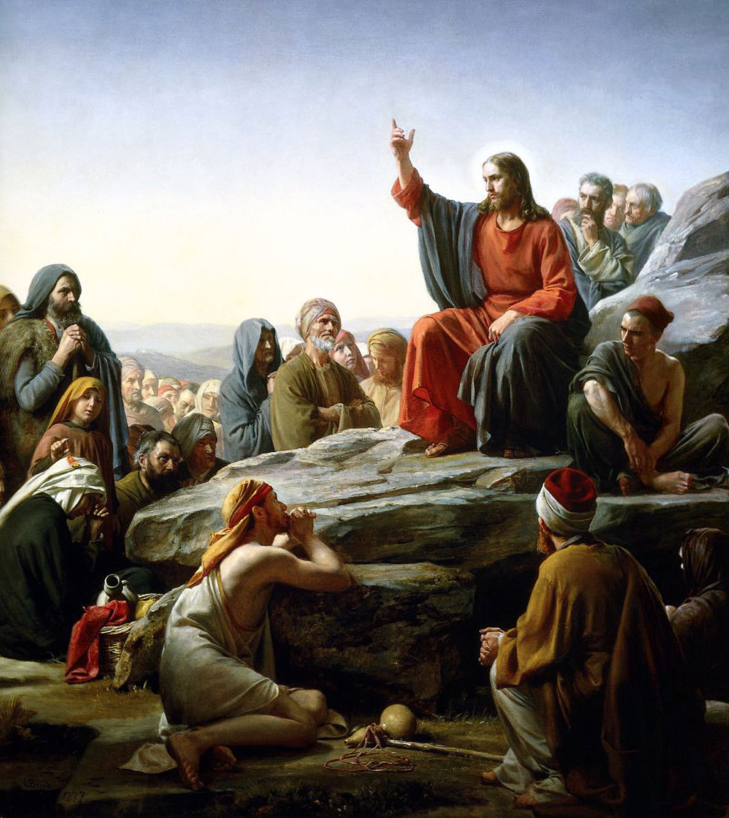
The Sermon on the Mount, Carl Bloch 1877 A.D.

For Further Discussion:
- How would you define a false prophet? What things might characterize a false teacher?
- There are always more people who profess Christ than follow him. What’s the difference?
- Why do you think Jesus places so much emphasis on obedience? Is obedience easy for you?

