Stories in the Gospels
Matthew 21.12-13

The Passover and the Temple

“Den of robbers” - Injustice and the worship of God

“House of trade” – Exchanging one God for another

Love and Judgment

Stories in the Gospels
Matthew 21.12-13

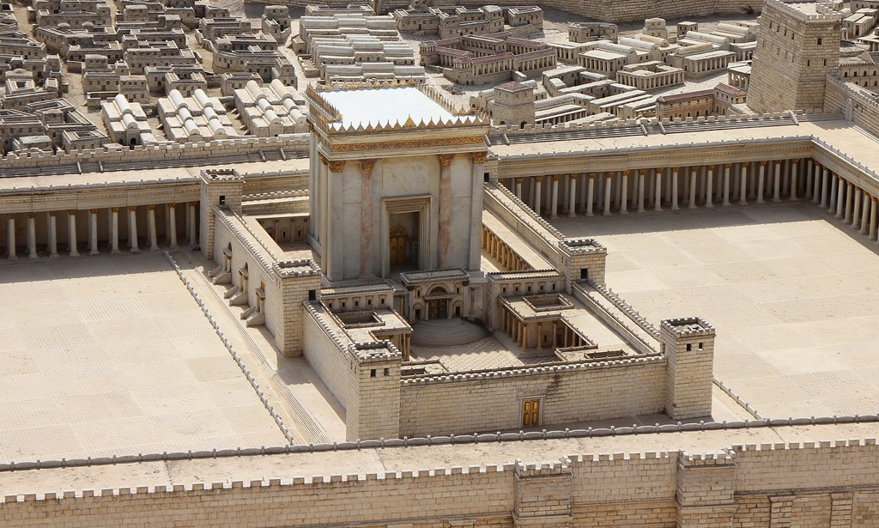
Model of the Temple in the Time of Jesus

For Further Discussion:
- Is it hard for you to imagine Jesus as angry? Why or why not?
- If you were a character in this story, who would you be? Jesus clearing the Temple, a moneychanger, a poor visitor to the Temple?
- Justice and mercy are characterized as “fruits of repentance”, or the outcome of placing our faith in Jesus. How do you reflect justice in your life?
- Why does true love make distinctions, judging good and evil?

