The Spirit of Christmas Past
Philippians 2:1-11

Christmas in the “3rd” World

Lessons from the Example of Jesus – Phil 2:9-11

So if there is any encouragement in Christ, any comfort from love, any participation in the Spirit, any affection and sympathy, ² complete my joy by being of the same mind, having the same love, being in full accord and of one mind. ³ Do nothing from selfish ambition or conceit, but in humility count others more significant than yourselves. ⁴ Let each of you look not only to his own interests, but also to the interests of others. ⁵ Have this mind among yourselves, which is yours in Christ Jesus, ⁶ who, though he was in the form of God, did not count equality with God a thing to be grasped, ⁷ but emptied himself, by taking the form of a servant, being born in the likeness of men. ⁸ And being found in human form, he humbled himself by becoming obedient to the point of death, even death on a cross. ⁹ Therefore God has highly exalted him and bestowed on him the name that is above every name, ¹⁰ so that at the name of Jesus every knee should bow, in heaven and on earth and under the earth, ¹¹ and every tongue confess that Jesus Christ is Lord, to the glory of God the Father.

Philippians 2:1-11 (English Standard Version)

The Spirit of Christmas Past
Philippians 2:1-11

Discussion:
- What have you been holding onto that you have decided to let go of?
- In the text of Philippians 2:8-11, Jesus humbles himself and is obedient, therefore God exalts him. Why do you think the text says “therefore”? What is the connection between humility, obedience and being exalted by God?
- How can Philippians 4:11-13 apply to your situation this year?

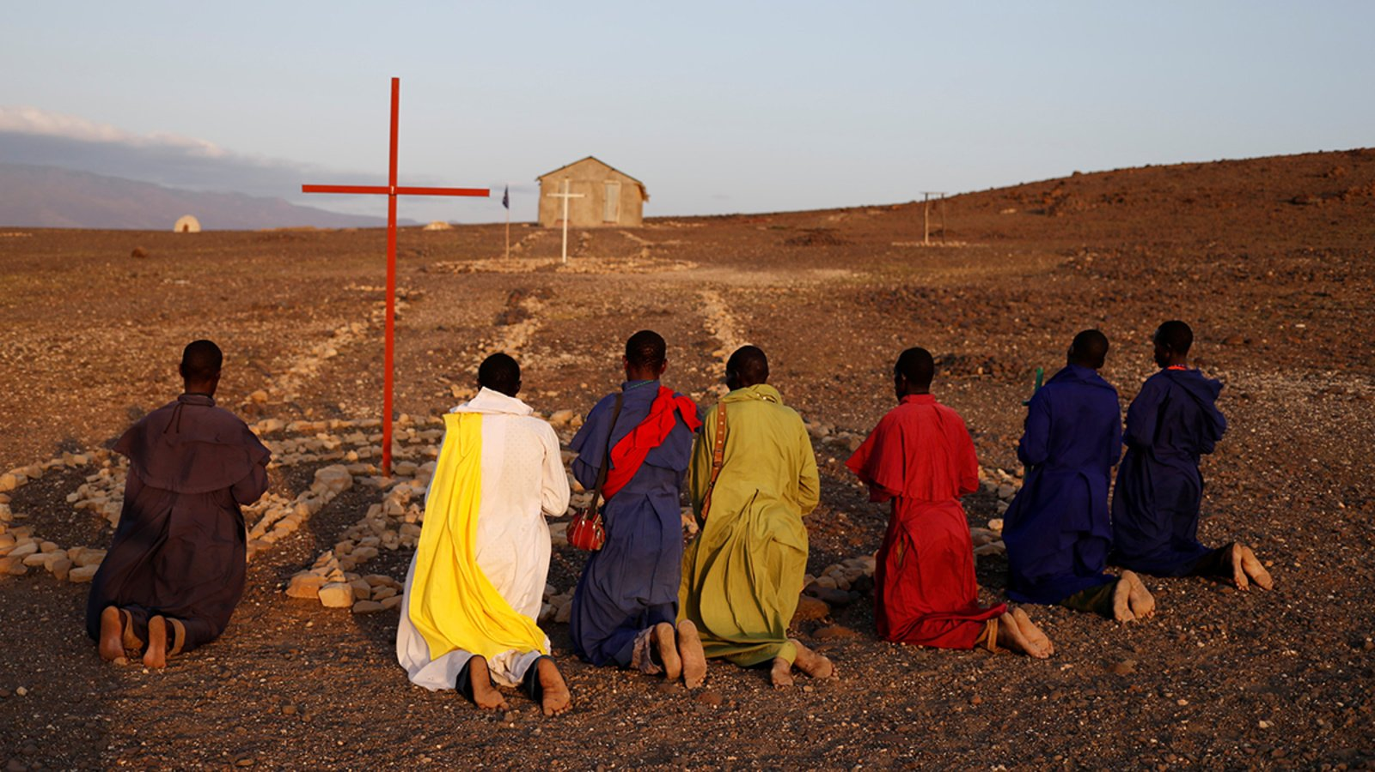
The Perfect Illustration of Philippians 2:10-11

