The Spirit of Christmas Past
Philippians 2:1-11

Christmas in North Korea, China, and Iran

Lessons from the Example of Jesus – Phil 2:8

So if there is any encouragement in Christ, any comfort from love, any participation in the Spirit, any affection and sympathy, ² complete my joy by being of the same mind, having the same love, being in full accord and of one mind. ³ Do nothing from selfish ambition or conceit, but in humility count others more significant than yourselves. ⁴ Let each of you look not only to his own interests, but also to the interests of others. ⁵ Have this mind among yourselves, which is yours in Christ Jesus, ⁶ who, though he was in the form of God, did not count equality with God a thing to be grasped, ⁷ but emptied himself, by taking the form of a servant, being born in the likeness of men. ⁸ And being found in human form, he humbled himself by becoming obedient to the point of death, even death on a cross. ⁹ Therefore God has highly exalted him and bestowed on him the name that is above every name, ¹⁰ so that at the name of Jesus every knee should bow, in heaven and on earth and under the earth, ¹¹ and every tongue confess that Jesus Christ is Lord, to the glory of God the Father.

Philippians 2:1-11 (English Standard Version)

The Spirit of Christmas Past
Philippians 2:1-11

Discussion:
- If you were giving the award for “Most Humble Person”, to whom would you present the award?
- What laws or rules are most difficult for you to obey? Why?
- How does the example of Jesus humbling himself to events and being obedient to God’s plan inspire you? What can you do differently this week to demonstrate humility?

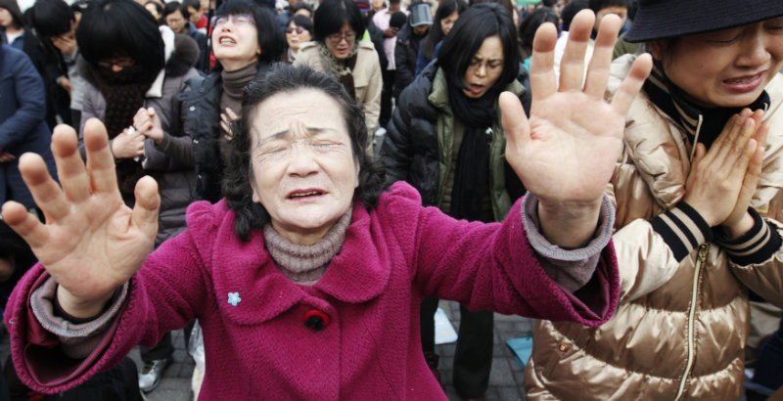
North Korean defectors claim 75% of Christians there die for their Faith

