The Spirit of Christmas Past
Philippians 2:1-11

Christmas in London, 1940

Lessons from the Example of Jesus – Phil 2:4-7

So if there is any encouragement in Christ, any comfort from love, any participation in the Spirit, any affection and sympathy, ² complete my joy by being of the same mind, having the same love, being in full accord and of one mind. ³ Do nothing from selfish ambition or conceit, but in humility count others more significant than yourselves. ⁴ Let each of you look not only to his own interests, but also to the interests of others. ⁵ Have this mind among yourselves, which is yours in Christ Jesus, ⁶ who, though he was in the form of God, did not count equality with God a thing to be grasped, ⁷ but emptied himself, by taking the form of a servant, being born in the likeness of men. ⁸ And being found in human form, he humbled himself by becoming obedient to the point of death, even death on a cross. ⁹ Therefore God has highly exalted him and bestowed on him the name that is above every name, ¹⁰ so that at the name of Jesus every knee should bow, in heaven and on earth and under the earth, ¹¹ and every tongue confess that Jesus Christ is Lord, to the glory of God the Father.

Philippians 2:1-11 (English Standard Version)

The Spirit of Christmas Past
Philippians 2:1-11

Discussion:
- How has the Covid virus (and its attendant quarantining for those exposed) affected your family?
- Does the example of the Britons during WW2 encourage you? Why or why not?
- In Philippians 4:11, Paul says he has learned the secret of being content. In light of our lesson, what are your thoughts on this secret?

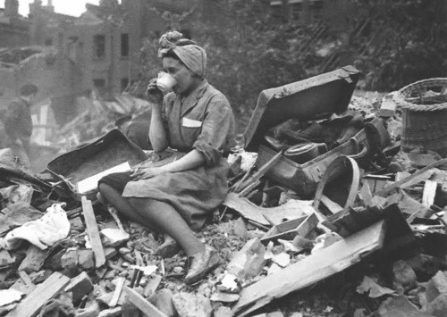
“Keep Calm and Carry On”, London 1940

