Stories to Live By – The Gospel of Luke
Luke 24 – The Resurrection Story

- Background and Context of Luke 24

- The Story – Resurrection

- Living by the Story

Stories to Live By – The Gospel of Luke
Luke 24 – The Resurrection Story

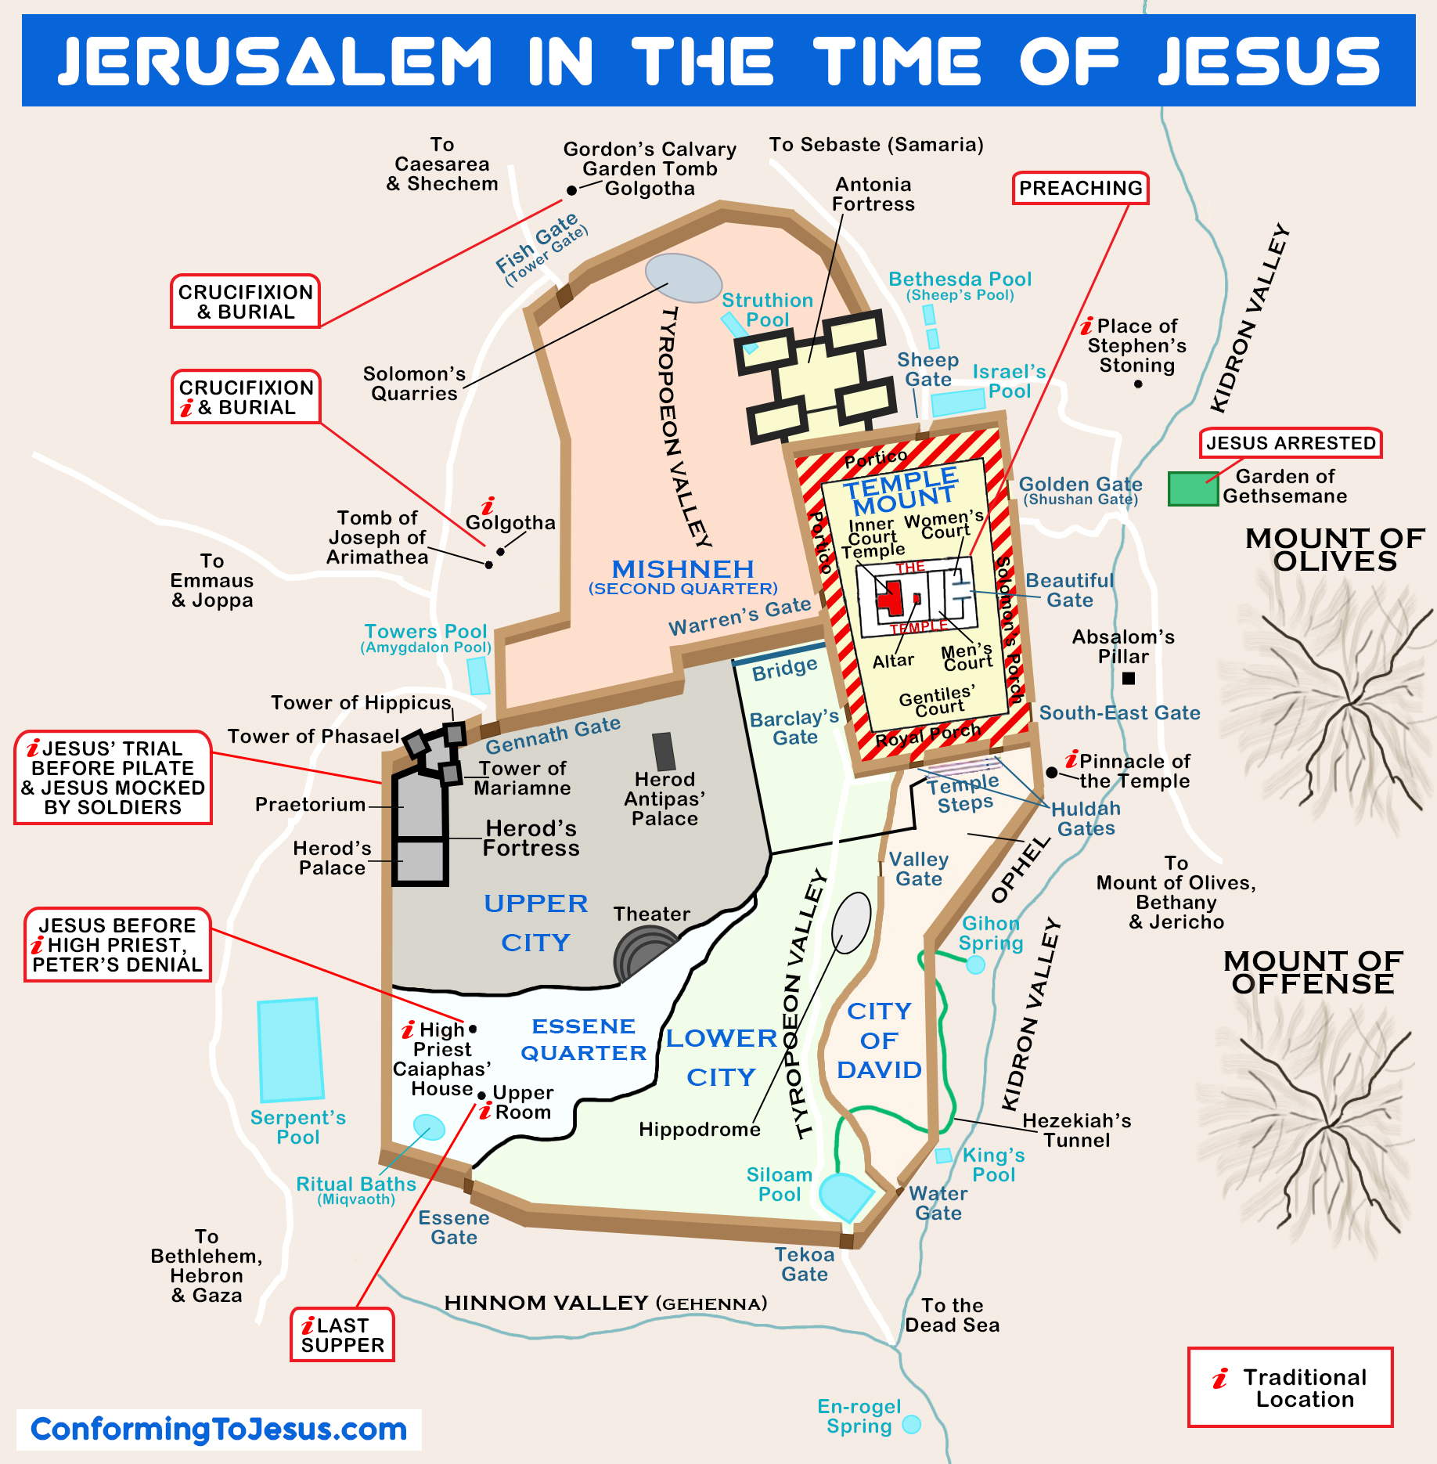
A Diagram of Possible Locations of Golgotha

Discussion:
- What would the Christian faith be like if the story ended with no resurrection?
- Do you agree with this statement, “There is no awareness of salvation without an awareness of sin?” Why or why not?
- Was (Is) your journey to belief easy or hard?
- How does the reality of the resurrection of Jesus affect your attitude toward life?

