Stories to Live By – The Gospel of Luke
Luke 21 – The Widow’s Offering

- Background and Context of Luke 21

- The Story – The Widow’s Offering

- Living by the Story

Stories to Live By – The Gospel of Luke
Luke 21 – The Widow’s Offering

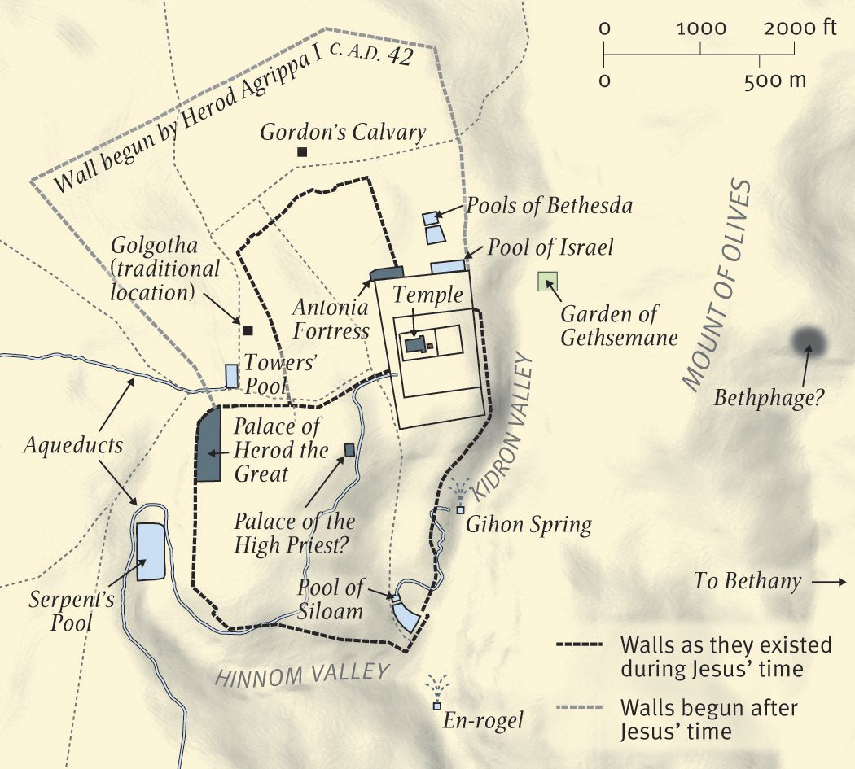
A Diagram of the Temple Area in the Time of Jesus

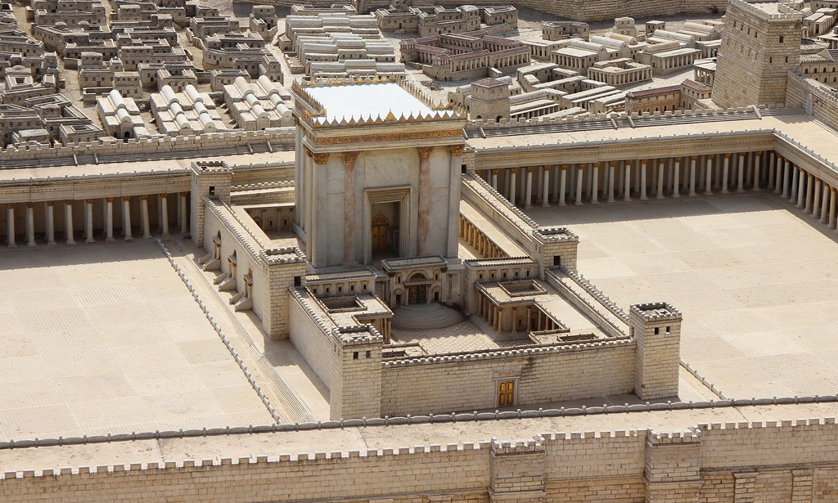
The Temple in the Time of Jesus

Discussion:
- Why do you think it is so hard to determine how much is enough?
- Can you recall a time when you were completely dependent on God? How did that affect your faith?
- What is one area of your life where you would like to depend on God more completely?
- How will you pray differently this week?

