Stories to Live By – The Gospel of Luke
Luke 8 – The Four Types of Soil

- Background and Context of Luke 8

- The Story – The Sower and the Soil

- Implications of the Story

Stories to Live By – The Gospel of Luke
Luke 8 – The Four Types of Soil

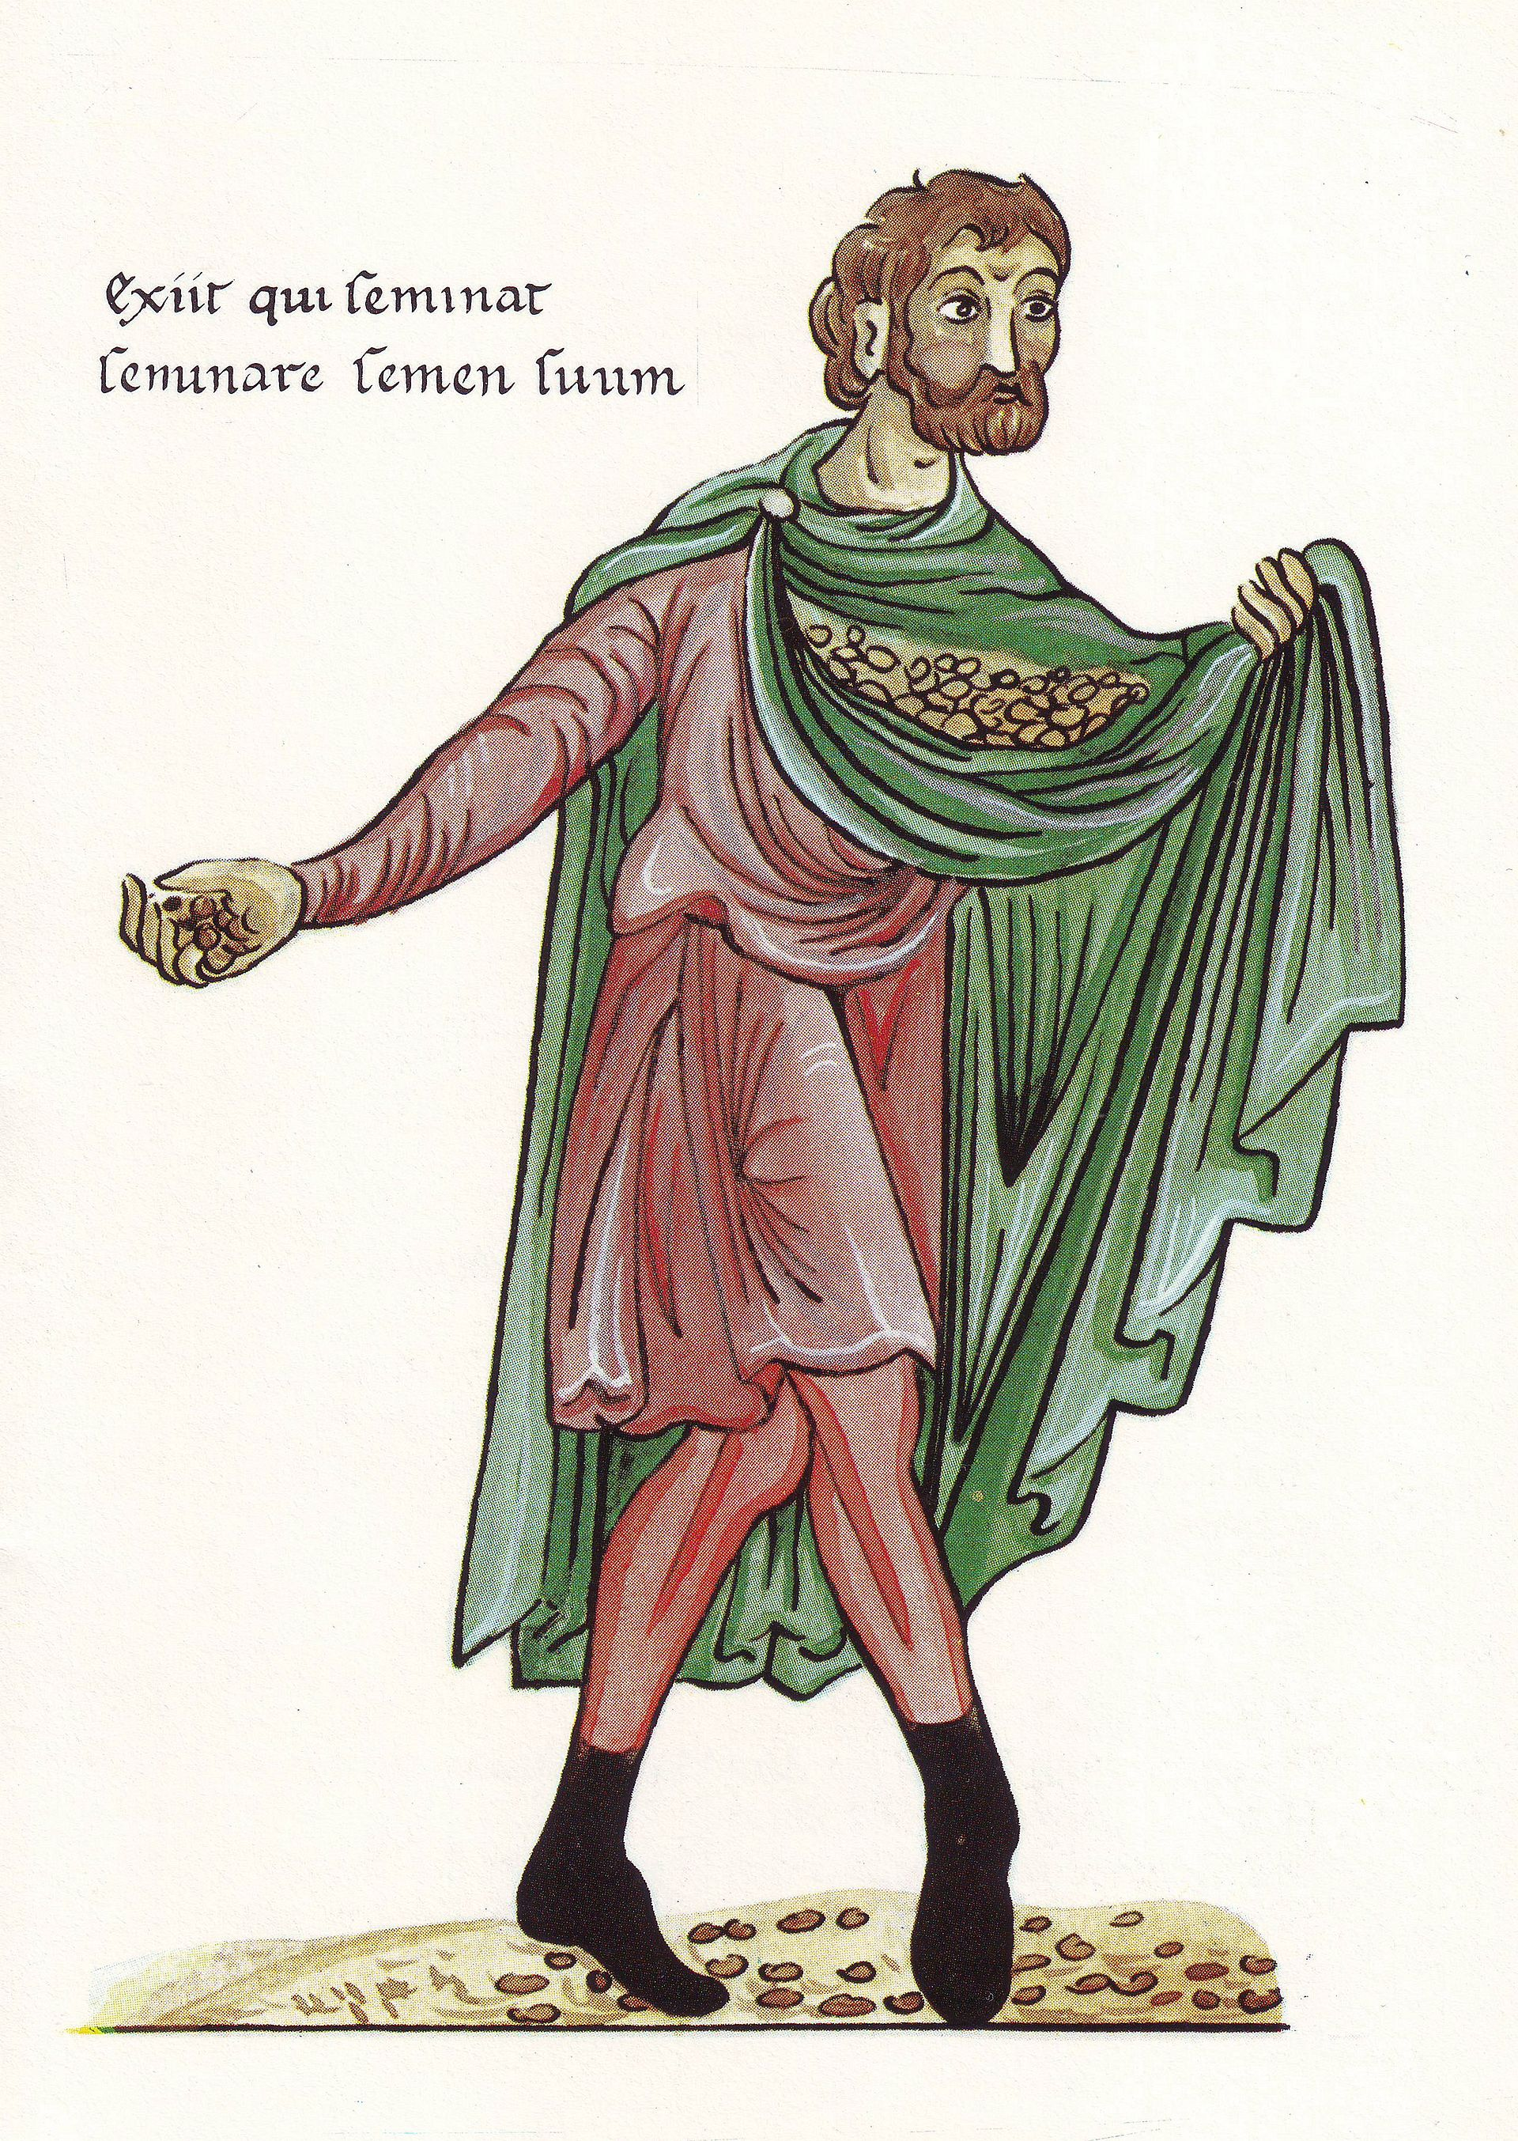
The Sower, 1180 A.D.
(Wikimedia Commons, CC-BY-SA 3.0)

Discussion:
- What does a fruitful life look like according to the standard of our world? How is this different for Christians?
- In what ways is belief in Jesus like a seed? How has this been true in your life?
- Many Christians relate that they felt “pursued” or “drawn” by God. What has been (or is now) your experience?

