Stories to Live By – The Gospel of Luke
Luke 4 – The Temptation of Christ

- Background and Context

- The Story – “The Temptation of Christ”

- Lessons to Live By:

Stories to Live By – The Gospel of Luke
Luke 4 – The Temptation of Christ

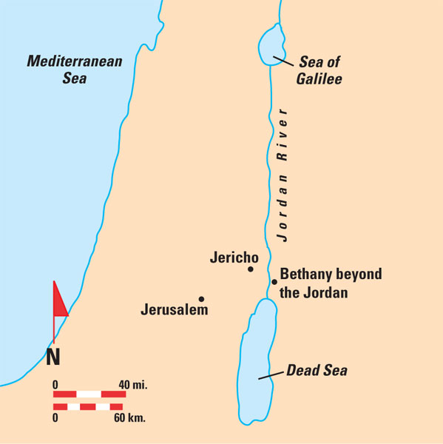
Site of the Baptism of Jesus, (see John 1:28)

Discussion:
- What parallels do you see between Jesus in the desert and the Israelites in the desert 1,400 years earlier?
- What areas of life present you with the most difficult temptations? Trials, pride, ambition?
- Luke 4 says Jesus was “led by the Spirit” into the desert. What does it look like to be led by the Spirit?

