Stories in Genesis: Creation

An Ancient Creation Story

A Modern Creation Story

The Biblical Account

What does the Creation account mean for us?

Stories in Genesis: Creation

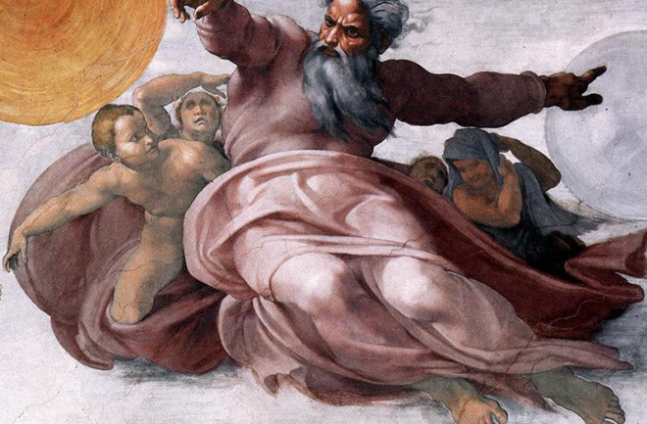
The Creation of the Heavens, from the Sistine Chapel
Michelangelo, 1508 A.D.

For Further Discussion:
- Describing how things work is the goal of the scientific method. Explaining the why of the universe is another matter. Do you think it is important to seek the answer to the question, “Why are we here?”
- The Bible represents our relationship to God in terms of adoption, family. How does that differ from the other two accounts?
- How do the three creation stories we discussed in the lesson affect the quality of life for their believers?

