Stories in Genesis: The Tower of Babel

The Fall of Humanity, the Sequel

Sin and the Separation of Humanity

Christ and the Unification of Humanity

Stories in Genesis: The Tower of Babel

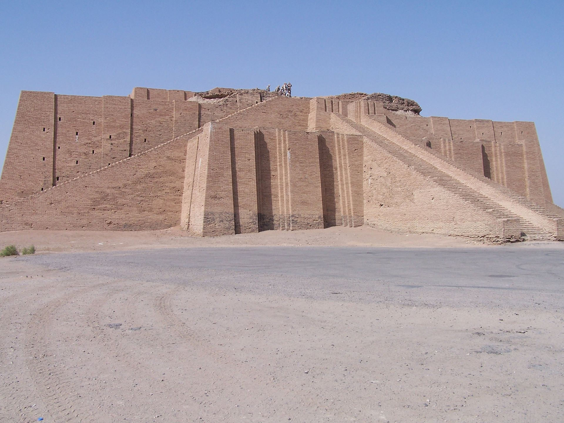
The Ziggurat of Ur with reconstructed façade; Originally built ca. 2000 BC in modern-day Iraq

For Further Discussion:
- One aspect of this story is God’s fragmentation of humanity by removing a common language. Can you think of examples of how language has continued to divide humanity since that time?
- Human pride sets humanity at odds with God in the Babel story. How does pride set us at odds with God today? With each other?
- A theme in Genesis chapters 1-11 is the human desire to pursue our own plans instead of God’s plans. How are the consequences for humanity in Genesis like the consequences today? How about for us personally?

