Stories in Genesis: The Flood

The Legacy of Cain

The “Nephilim” of Genesis 6

Noah and the Flood

The Bid Ideas and the Practical Implications

Stories in Genesis: The Flood

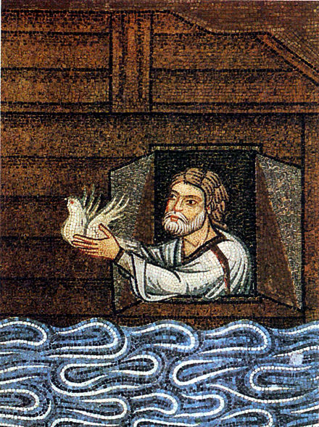
12th Century Mosaic of Noah releasing the Dove

For Further Discussion:
- The time between Cain and Noah was a period of violating God’s boundaries, i.e. sin. How do you see this crossing of boundaries manifesting itself in human nature today?
- The story of the Nephilim, or giants, is intriguing because of its mystery. However, it is recorded in the Bible for reasons other than mystery. What lessons or points do you think the story of the Nephilim is trying to make to us?
- The Flood is an example of God’s justice; for example, consider the victims of the violence of the time. What echoes of this can you spot in the Gospel story?

