Stories in Genesis: The Fall of Humanity

Temptation in Paradise

Free Will and the Problem of Evil

The Consequences of Sin

Implications for Us

Stories in Genesis: The Fall of Humanity

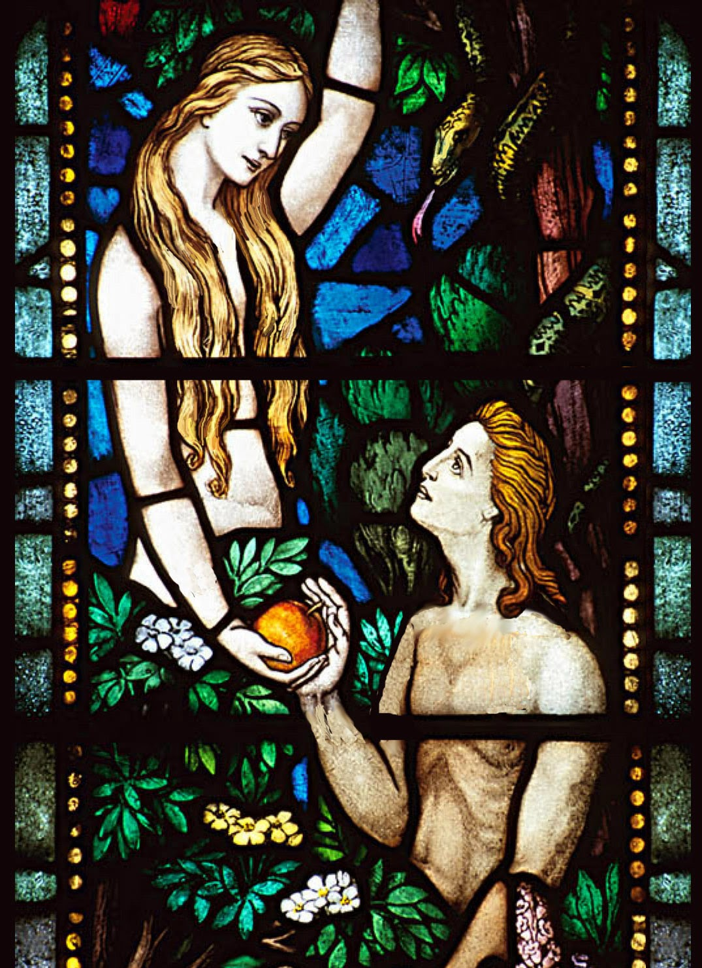

For Further Discussion:
- Some elements of the story in Genesis chapter 3 are puzzling and others are very clear. What are the clear themes that stand out to you?
- One way to look at the story of the Fall is in terms of its explanatory power for modern human experience. Do you think the Fall makes sense of the world as we know it?
- Sometimes people blame God for evil and tragedy because he has the power to prevent it. What would happen if God overrode human will on a regular basis?

