Stories in Genesis: Adam and Eve

Imago Dei, The Image of God

Eden, A Theology of Work

No Shame Before God

Was there a real Adam and Eve?

Stories in Genesis: Adam and Eve

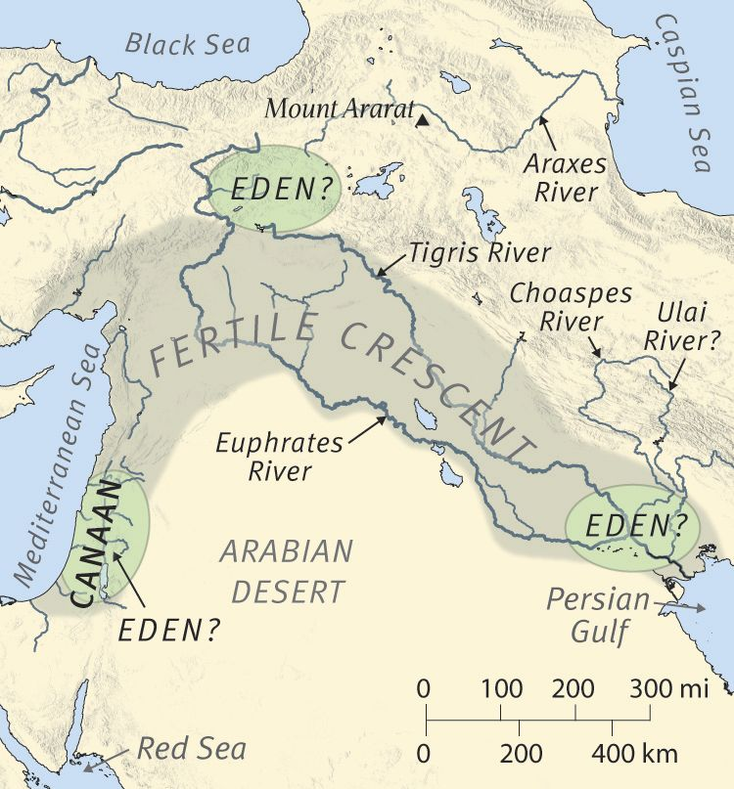
Possible locations for the Garden of Eden

For Further Discussion:
- The creation of humanity in the “image of God” is a rich and complex idea. Sometimes clarity is found in simplicity; how would you explain this truth to a child?
- It is obvious how being created male and female furthers the purpose of “filling the earth”. How do you think it furthers God’s spiritual plan for us?
- Why do you think Adam and Eve “were not ashamed” in their nakedness? What is the significance of this statement in the creation account?
- Do you have a hard time accepting the creation of Adam and Eve by a direct act of God? Share why or why not.

