Leadership For Modern Times
A Study of Nehemiah – Part 8

Between the Testaments: Nehemiah to Jesus

The Four Great Empires of Daniel’s Vision:
- Babylon 605 – 539 BC
- Persia 539 – 331 BC
- Greece 331 – 168 BC
- Rome 168 BC – 476 AD

King Antiochus and the Maccabean Rebellion

The Roman Empire

King Herod

Leadership For Modern Times
A Study of Nehemiah – Part 8

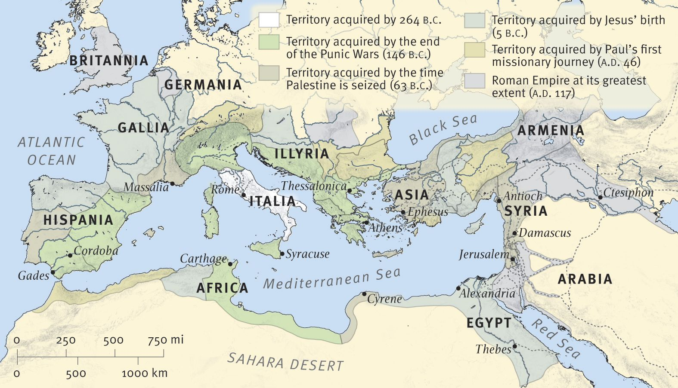
The Roman Empire in New Testament Times

For Further Discussion:
- As you think about the succession of kingdoms leading up to Jesus, how can you see God’s working to set the stage?
- Do you think God is still architecting events for a purpose? Why and at what level of detail do you think he is working in the modern world?
- How do you think God has been and is now working in your life? Do you see signs of his concern for you?

