Leadership For Modern Times
A Study of Nehemiah – Part 7

Between the Testaments: Nehemiah to Jesus

Daniel and the Four Great Empires
- Babylon 605 – 539 BC
- Persia 539 – 331 BC
- Greece 331 – 168 BC
- Rome 168 BC – 476 AD

Timeline
605–538 BC Daniel is in Babylon
586 BC Babylon destroys Jerusalem and the temple
539 BC The Persians conquer Babylon
536 BC Some Jews return to Jerusalem to rebuild the temple (Ezra 1-6)
484-465 BC Esther is queen in Persia (Esther)
480 BC Athenians and Spartans defeat Xerxes, king of Persia
465-424 BC Artaxerxes is king of Persia
458-444 BC Ezra comes to Jerusalem to restore worship (Ezra 7-10)
444 BC Nehemiah comes to Jerusalem to rebuild the walls (Nehemiah)
Leadership For Modern Times
A Study of Nehemiah – Part 7

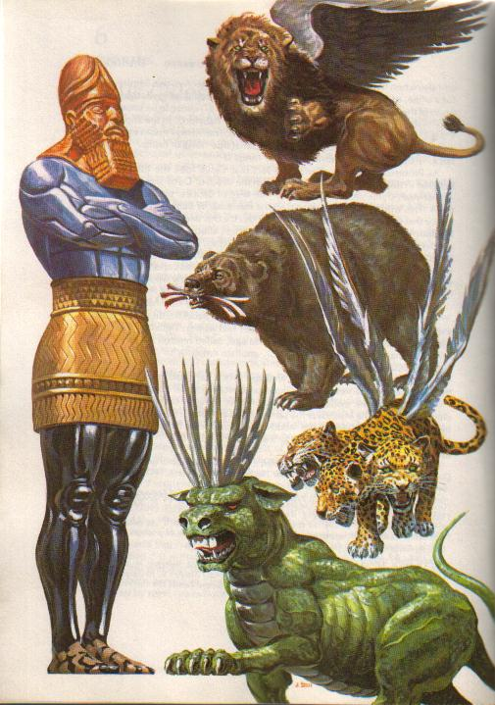
Daniel’s Visions of the Statue and the Beasts

For Further Discussion:
- Daniel’s vision is a roadmap of the political events between the Old and New Testament. Why do you think God revealed this information?
- How was God weaving together spiritual events and temporal, political events to achieve his purpose?
- Do you think God has a plan now like he did then?

