Leadership For Modern Times
A Study of Nehemiah – Part 5

Leadership Principles:
- Pray. Commit your endeavors to God.

- Prepare. Expect God to move.

- Commit. What are you willing to give?

- Expect Opposition. Challenges refine leaders.

- ______________________________

Nehemiah 5 - Resistance from Internal Foes

Timeline
605–538 BC Daniel is in Babylon
586 BC Babylon destroys Jerusalem and the temple
539 BC The Persians conquer Babylon
536 BC Some Jews return to Jerusalem to rebuild the temple (Ezra 1-6)
484-465 BC Esther is queen in Persia (Esther)
480 BC Athenians and Spartans defeat Xerxes, king of Persia
465-424 BC Artaxerxes is king of Persia
458-444 BC Ezra comes to Jerusalem to restore worship (Ezra 7-10)
444 BC Nehemiah comes to Jerusalem to rebuild the walls (Nehemiah)
Leadership For Modern Times
A Study of Nehemiah – Part 5

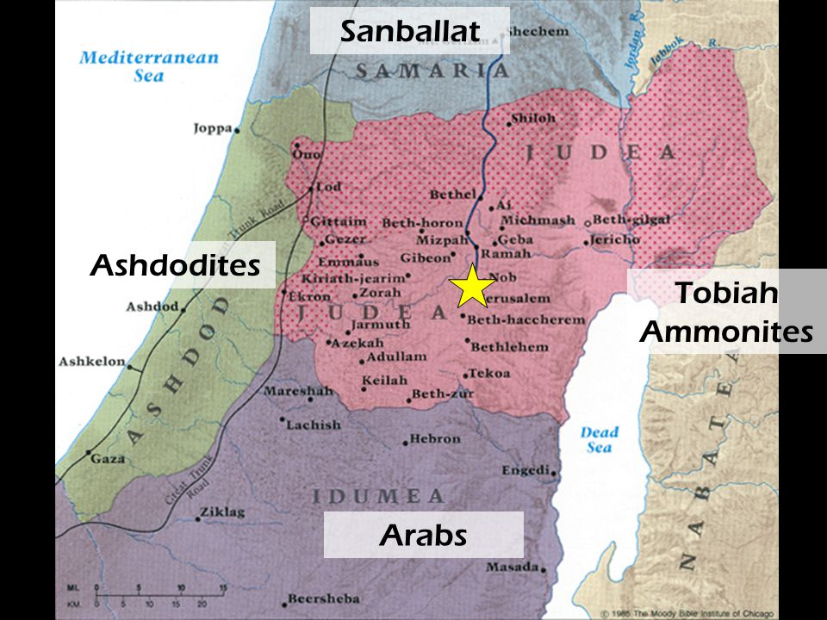
The Area of Israel in the time of Nehemiah, ca. 444 B.C.

For Further Discussion:
- Why is resistance from within our group more difficult and devastating than resistance from outside?
- How did Nehemiah approach the internal problems? To what did he appeal to get their attention?
- In Chapter 6, verse 9, Nehemiah says “O God, strengthen my hands.” What do you think he meant? Do you have a situation in your life where you might need to pray this prayer?

