Leadership For Modern Times
A Study of Nehemiah – Part 4

Leadership Principles:
- Pray. Commit your endeavors to God.

- Prepare. Expect God to move.

- Commit. What are you willing to give?

- ______________________________

Nehemiah 4 - Resistance from External Foes

Timeline
605–538 BC Daniel is in Babylon
586 BC Babylon destroys Jerusalem and the temple
539 BC The Persians conquer Babylon
536 BC Some Jews return to Jerusalem to rebuild the temple (Ezra 1-6)
484-465 BC Esther is queen in Persia (Esther)
480 BC Athenians and Spartans defeat Xerxes, king of Persia
465-424 BC Artaxerxes is king of Persia
458-444 BC Ezra comes to Jerusalem to restore worship (Ezra 7-10)
444 BC Nehemiah comes to Jerusalem to rebuild the walls (Nehemiah)
Leadership For Modern Times
A Study of Nehemiah – Part 4

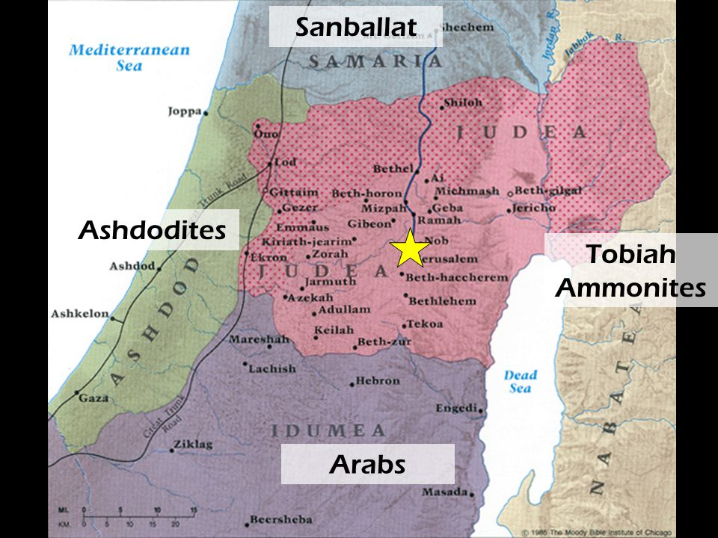
The Area of Israel in the time of Nehemiah, ca. 444 B.C.

For Further Discussion:
- Would you say you are an optimist or pessimist? Is your default expectation for things to go well or poorly?
- What do you think about Nehemiah’s philosophy to “say a prayer and post a guard?”
- How have challenges grown your abilities in the past?
- How can you apply Nehemiah’s approach to events in your life right now?

