Leadership For Modern Times
A Study of Nehemiah – Part 3

Leadership Principles:
- Pray. Commit your endeavors to God.

- Prepare. Expect God to move.

- ______________________________

Nehemiah 2:9 – 3 The Building Begins

Timeline
605–538 BC Daniel is in Babylon
586 BC Babylon destroys Jerusalem and the temple
539 BC The Persians conquer Babylon
536 BC Some Jews return to Jerusalem to rebuild the temple (Ezra 1-6)
484-465 BC Esther is queen in Persia (Esther)
480 BC Athenians and Spartans defeat Xerxes, king of Persia
465-424 BC Artaxerxes is king of Persia
458-444 BC Ezra comes to Jerusalem to restore worship (Ezra 7-10)
444 BC Nehemiah comes to Jerusalem to rebuild the walls (Nehemiah)
Leadership For Modern Times
A Study of Nehemiah – Part 3

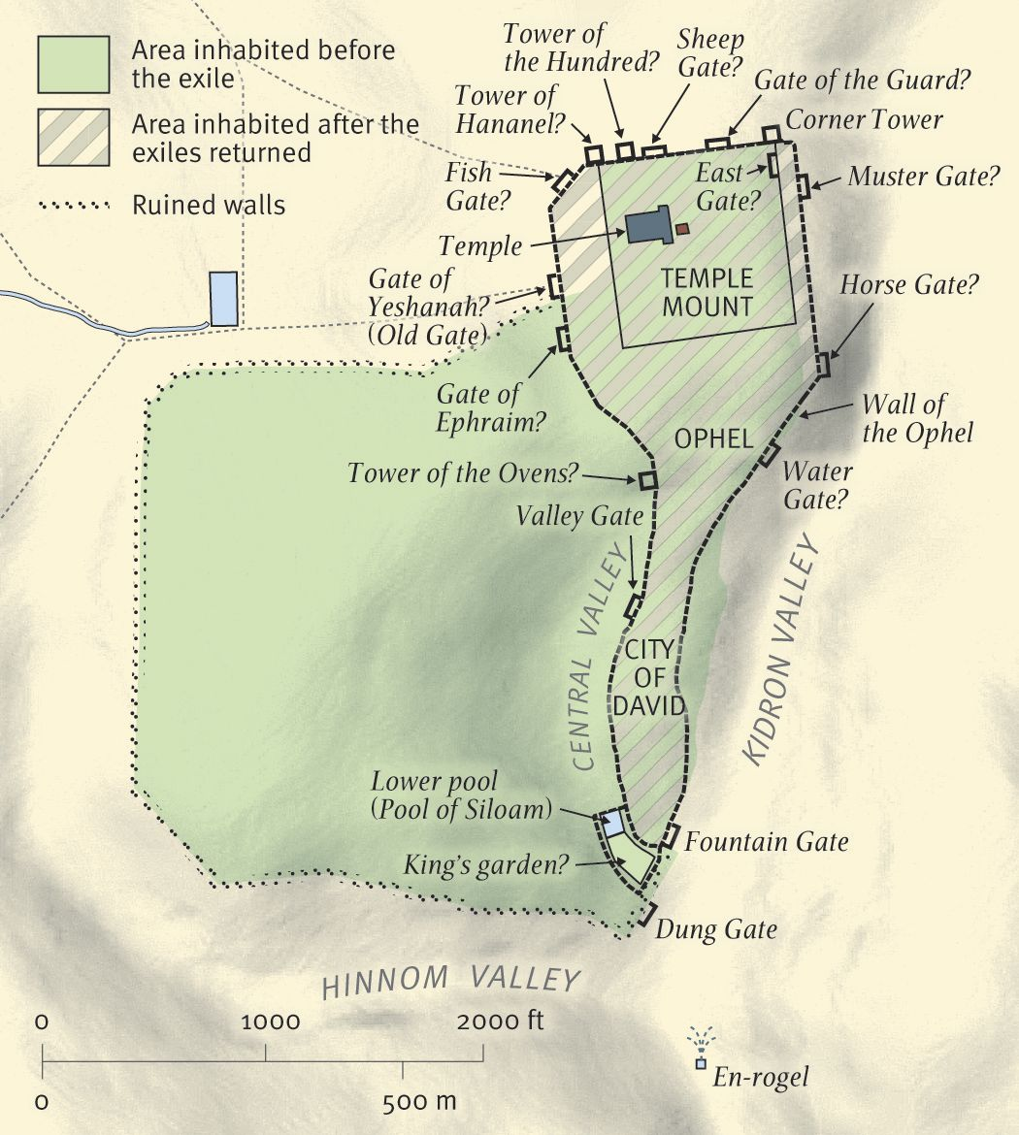
Jerusalem in the time of Nehemiah, ca. 444 B.C.

For Further Discussion:
- Nehemiah surveys the task of building before beginning work. How have you done this (or not!) in your life and work?
- The people are motivated when Nehemiah tells them what God has already done. Do you think telling the story of how God worked in your life would encourage others? Share some of your story.

