Leadership For Modern Times
A Study of Nehemiah – Part 2

Nehemiah 2:1-8

Timeline
605–538 BC Daniel is in Babylon
586 BC Babylonians destroy Jerusalem and the temple
539 BC The Persians conquer Babylon
536 BC Some Jews return to Jerusalem to rebuild the temple (Ezra 1-6)
484-465 BC Esther is queen in Persia (Esther)
480 BC Athenians and Spartans defeat Xerxes, king of Persia
465-424 BC Artaxerxes is king of Persia
458-444 BC Ezra comes to Jerusalem to restore worship (Ezra 7-10)
444 BC Nehemiah comes to Jerusalem to rebuild the walls (Nehemiah)
Leadership For Modern Times
A Study of Nehemiah – Part 2

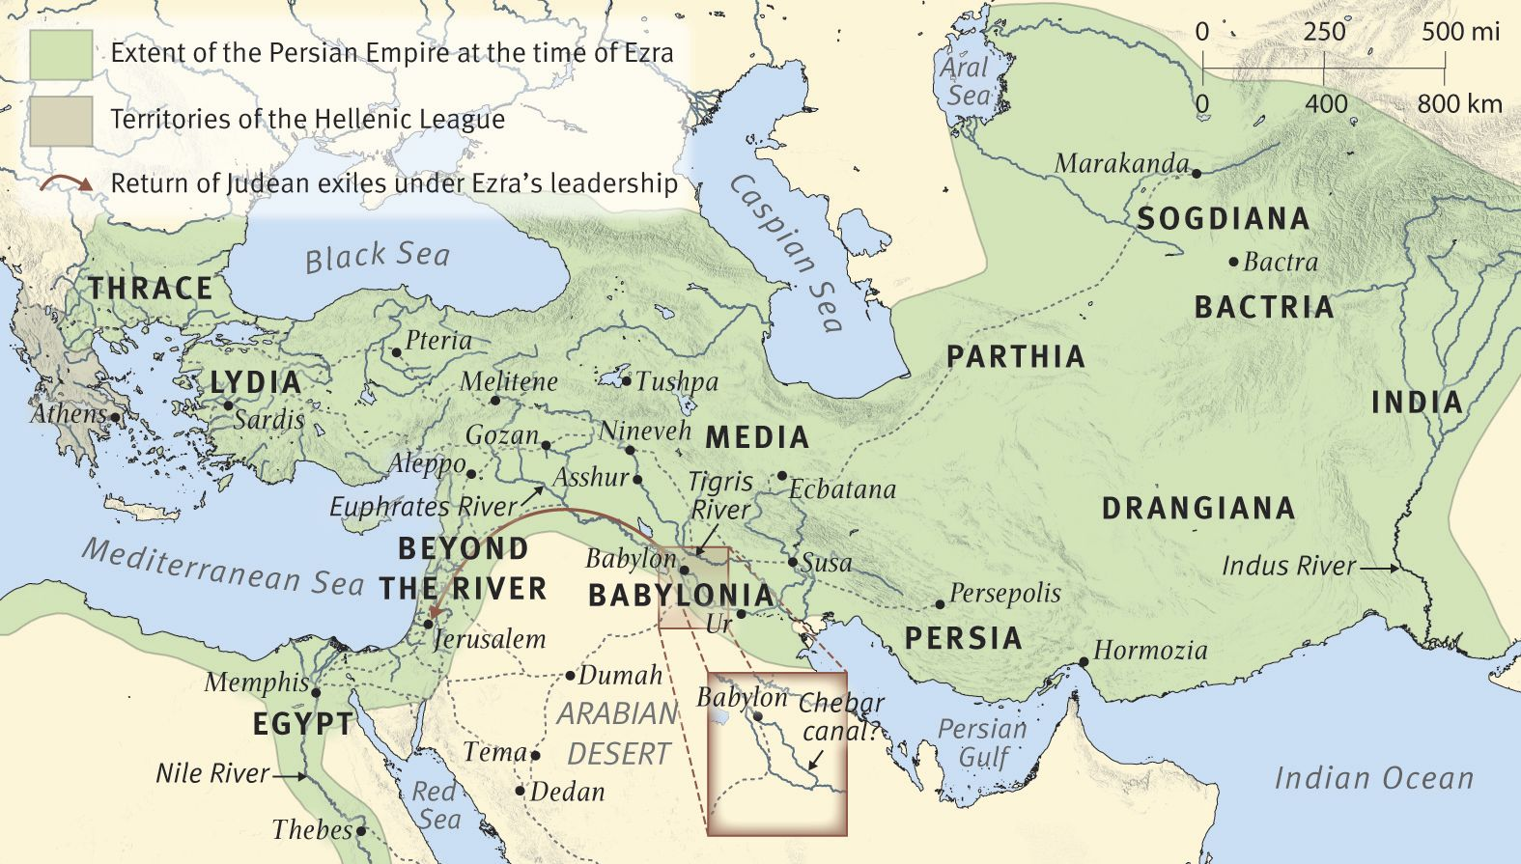
The Persian Empire in the Time of Nehemiah, circa 444 B.C.

For Further Discussion:
- When you consider the timeframe between Nehemiah’s first prayer in chapter 1 and his approach to the king in chapter 2, are you surprised? Is it hard for you to pray for something over a long period without an answer?
- In Nehemiah 2, verse 2, the test tells us that when the King asked what was wrong, Nehemiah was very much afraid. Why do you think that was? What confrontations in your life make you most anxious or afraid?
- In chapter 2, verse 4, Nehemiah says a quick prayer to God before he answers the King. Have you considered incorporating small prayers to God all throughout the day?

