Leadership For Modern Times
A Study of Nehemiah – Part 1

Nehemiah 1:1-11

Timeline
605–538 BC Daniel is in Babylon
586 BC Babylonians destroy Jerusalem and the temple
539 BC The Persians conquer Babylon
536 BC Some Jews return to Jerusalem to rebuild the temple (Ezra 1-6)
484-465 BC Esther is queen in Persia (Esther)
480 BC Athenians and Spartans defeat Xerxes, king of Persia
465-424 BC Artaxerxes is king of Persia
458-444 BC Ezra comes to Jerusalem to restore worship (Ezra 7-10)
444 BC Nehemiah comes to Jerusalem to rebuild the walls (Nehemiah)

Leadership For Modern Times
A Study of Nehemiah – Part 1

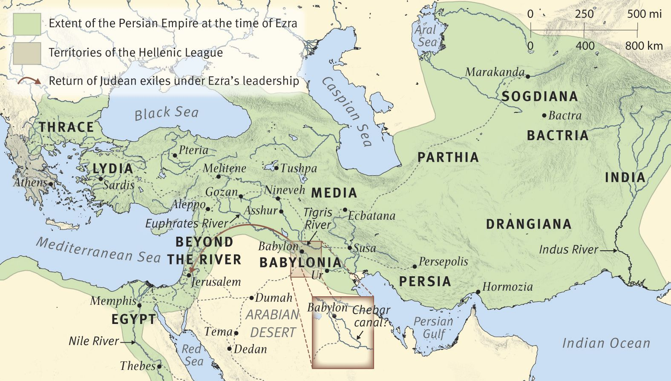
The Persian Empire in the Time of Nehemiah, circa 444 B.C.

For Further Discussion:
- Nehemiah prays to God to intervene in the process of asking the King for help. Do you think God intervenes in circumstances today? If so, how do you think he intervenes?
- When difficulties arise, is prayer your first resort or your last resort?
- Nehemiah places his talents at God’s disposal. Which of your talents do you think God can use? Which of your talents are available to God?

