The Making of Modern Israel
Part 2: World War 2 and the State of Israel

Between the Wars – Zionism and Early Settlement

World War 2 and the Holocaust

Establishment of the Jewish State and the War for Independence

The Making of Modern Israel
Part 2: World War 2 and the State of Israel

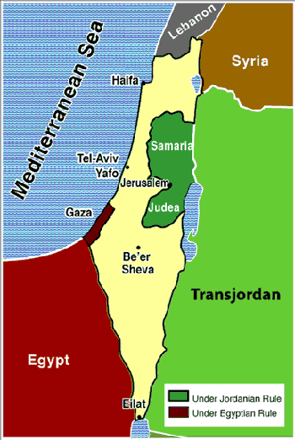
The State of Israel in 1949

For Further Discussion:
- If you were living at the end of World War 2, would you have thought the establishment of the Jewish state was a good idea? Why or why not?
- Historically, it is amazing that the Jewish people survived as an ethnic-cultural-religious entity after the Holocaust and the 1948 War. To what do you attribute the tenacity of this people?
- What are some key takeaways from this lesson?

