The Making of Modern Israel
Part 1: World War I

The Promised Land

The Arabs and Islam

The Dispersion (Diaspora) of the Jews
(The Roman Era to WW2)

The Making of Modern Israel
Part 1: World War I

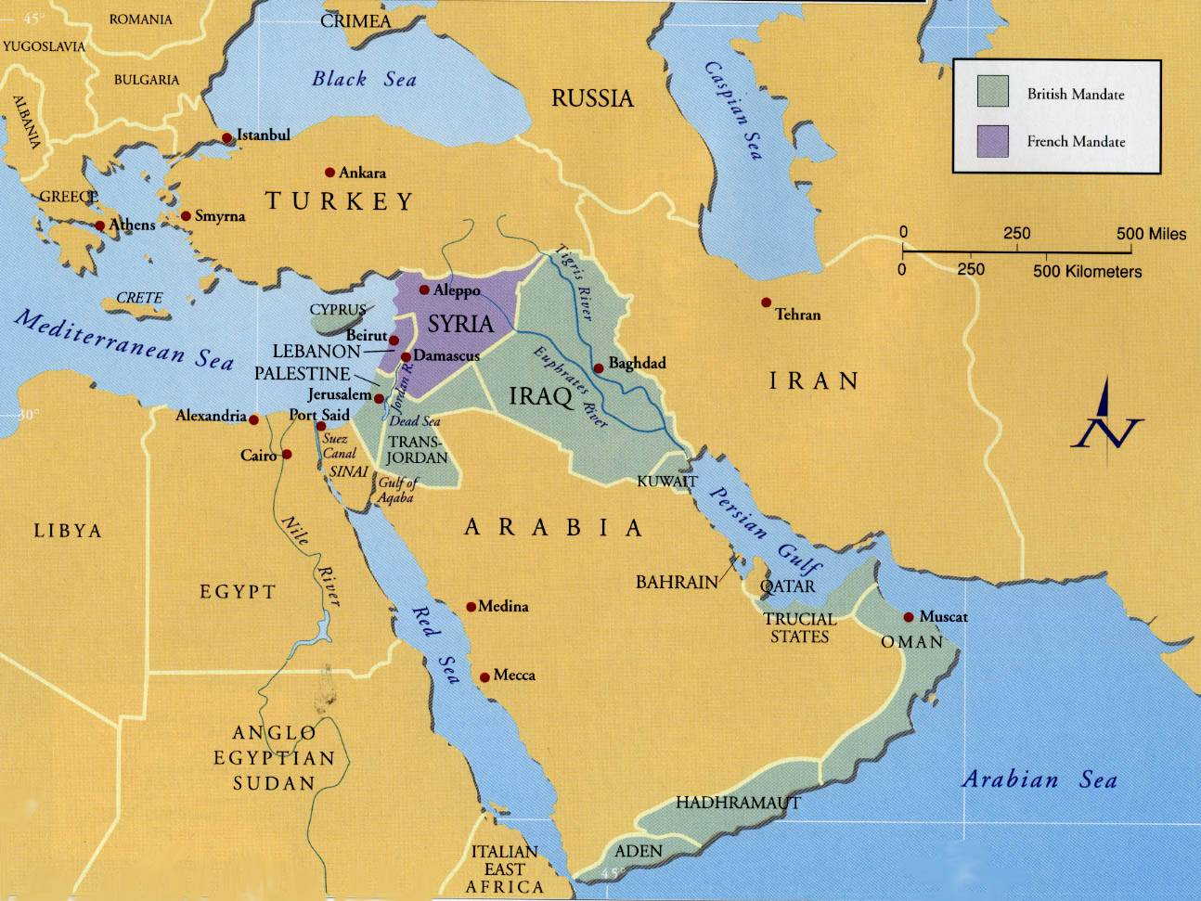
The Middle East at the beginning of World War 2

For Further Discussion:
- Historically, Christians have held a variety of views toward the Jewish religion, from support to tolerance to persecution. What would you say is the view among your circle of influence?
- How significant to you is your lineage or the ethnic origins of your family line? How does your experience affect your understanding of people with long ethnic histories?
- How does your Christian faith influence your identity?

