The Making of Modern Israel
Part 4: Modern Israel

Israel after the 1973 Yom Kippur War

The PLO and the Intifada

Modern Israel and the Middle East

The Making of Modern Israel
Part 4: Modern Israel

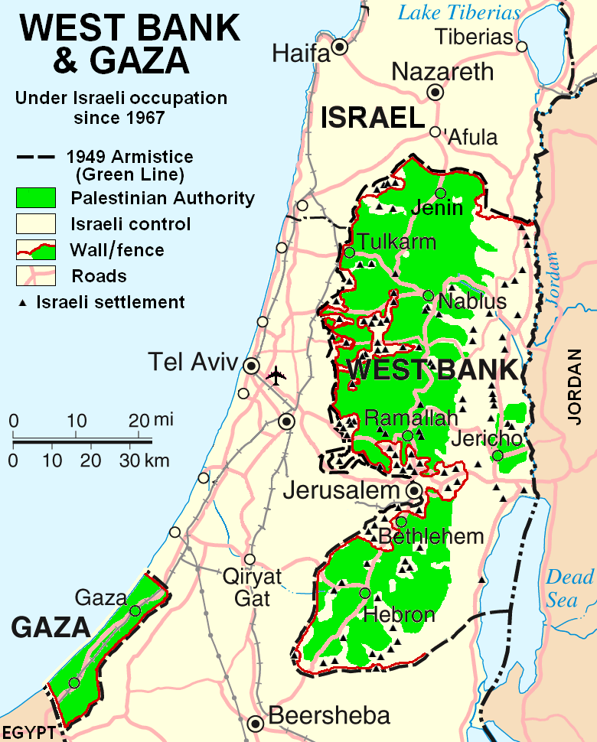
Modern Israel with West Bank and Gaza

For Further Discussion:
- Winston Churchill once said that in international relations there are no permanent friends or eternal enemies. Do you agree?
- As citizens of the U.S. what do you think are our interests in the Middle East?
- As citizens of the Kingdom of God, what are our interests in the Middle East?

