The Making of Modern Israel
Part 3: The Six-Day War and Yom Kippur War

From 1948 until 1967

6-Day War - 1967

Yom Kippur War - 1973

The Making of Modern Israel
Part 3: The Six-Day War and Yom Kippur War

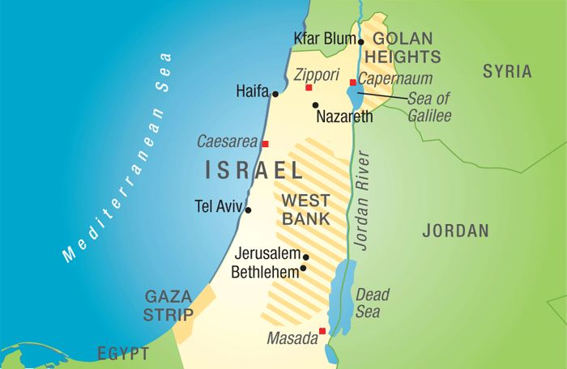
Modern Israel since Yom Kippur (1973) War

For Further Discussion:
- One obvious lesson from 1967-1973 is that the disunity of the Arab world contributed to their inability to achieve their goals. What lessons might we take from this to apply to the church today?
- Another lesson from this period is that, despite political factions, Israel was completely united in the face of possible extinction. What lessons might we take from this to apply to the church today?
- To what do you attribute Israel’s continued success and existence?

