The Life of David: A Study of 1 & 2 Samuel
Lesson 7 – A Very Human King

Historical Context

Story: 2 Samuel 10-14

Discussion:
- Unfortunately, the consequences of sin often involve the innocent. Who suffered due to David’s sin with Bathsheba?
- It would have been easy for David to have Nathan the prophet killed. Would you be brave enough to do what Nathan did? How do Christians “speak truth to power” today?
- When David’s oldest son and heir, Amnon, raped Tamar, the text says David was very displeased at this evil. Why do you think David took no action?
The Life of David: A Study of 1 & 2 Samuel
Lesson 7 – A Very Human King

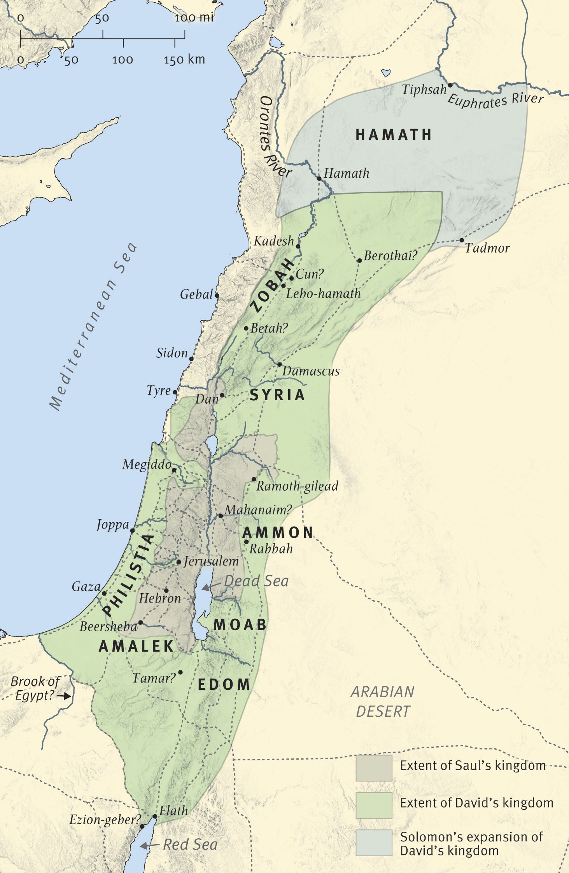
David’s Kingdom, circa 970 BC

