The Life of David: A Study of 1 & 2 Samuel
Lesson 6 – The Reign of David

Historical Context

Story: 2 Samuel 5-9

Discussion:
- The story of Uzzah and the Ark is difficult for us because we do not see the harm in touching the Ark. This is partly because our society has little sense of the idea of holiness. What does it mean for God to be holy? What does it mean for us to be holy?
- In 2 Samuel 7:18, David recounts his “story” and God’s goodness to him. When you look back on your life can you see a story of God’s activity? Share your ‘David story’.
- As you contemplate David’s treatment of Mephi-bosheth, what impresses you most about this story?

The Life of David: A Study of 1 & 2 Samuel
Lesson 6 – The Reign of David

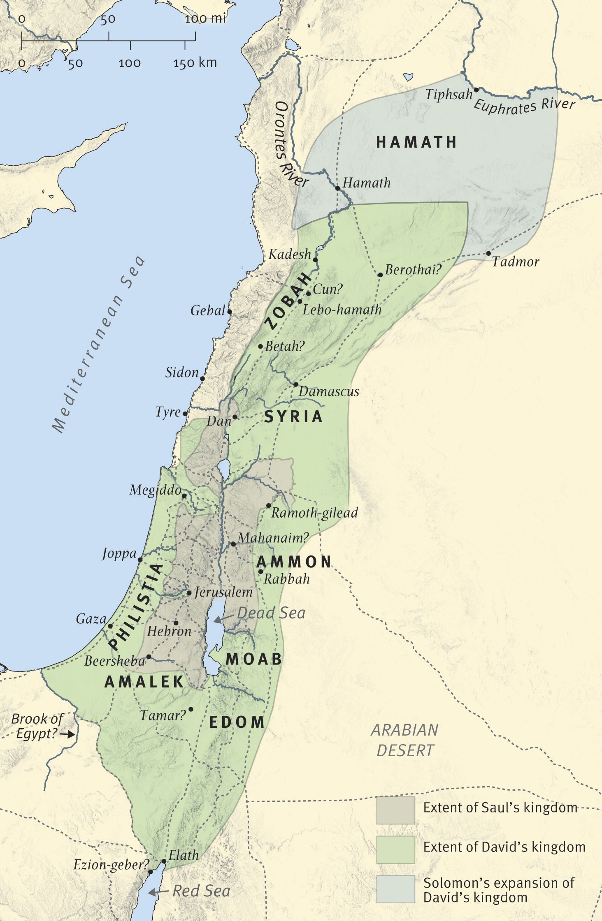
David’s Kingdom, circa 970 BC

