The Life of David: A Study of 1 & 2 Samuel
Lesson 5 – David Becomes King

Historical Context

Story: 2 Samuel 1-5

Discussion:
- It has been said that division and disunity are the Devil’s tools. How do you see this playing out in the vendetta between Joab and Abner? How have you seen it play out in your spiritual life?
- When Jesus stood before Pontius Pilate, he said that he could command legions of angels. Yet, Jesus chose the path of sacrifice over vengeance, healing over division. When have you made this choice, rightly or wrongly, and how did it turn out?
- Rabbi David Wolpe has called the Psalms “the Bible’s shining example of a single soul’s devotional reach toward God.” How do you think we should read the Psalms of David today? Are they primarily historical or primarily a guide for us?

The Life of David: A Study of 1 & 2 Samuel
Lesson 5 – David Becomes King

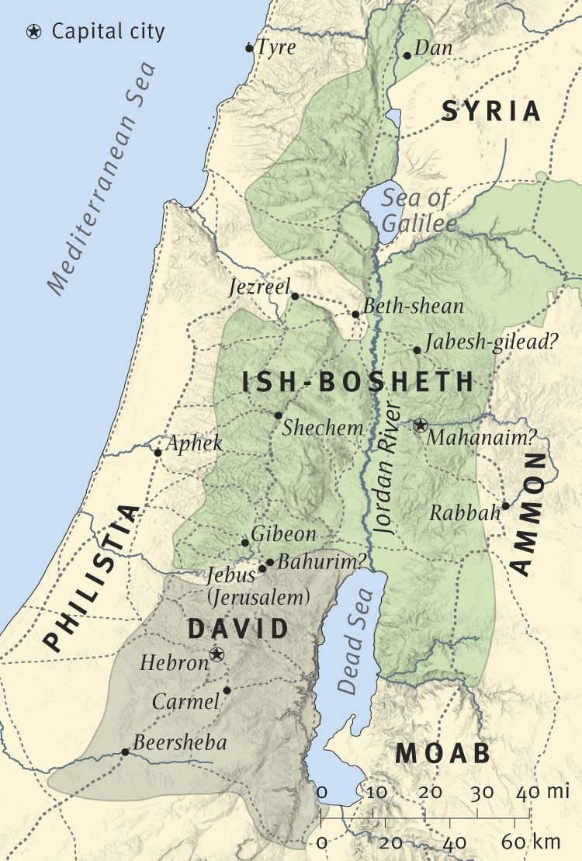
After Saul’s Death, David becomes King over Judah

