The Life of David: A Study of 1 & 2 Samuel
Lesson 4 – David Joins the Philistines

Historical Context

Story: 1 Samuel 27-31

Discussion:
- When you read stories in the Bible that are not flattering to God’s people, does it increase or decrease your confidence in the Bible?
- Eugene Peterson says that God works out his plan and purpose through an imperfect church and people who are in the process of being perfected. Does this encourage or discourage you?
- When Saul dies, the Israelites have been conquered and fled their cities, their situation is as grave as ever. Why do you think God might have waited until this point to make David king?

The Life of David: A Study of 1 & 2 Samuel
Lesson 4 – David Joins the Philistines

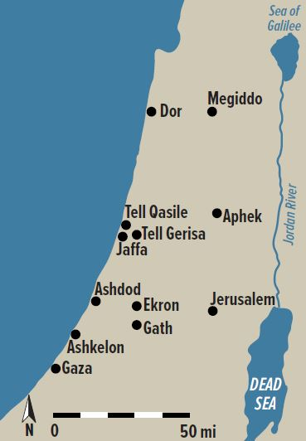
Key Cities in the Reign of Saul, ca. 1010 B.C.

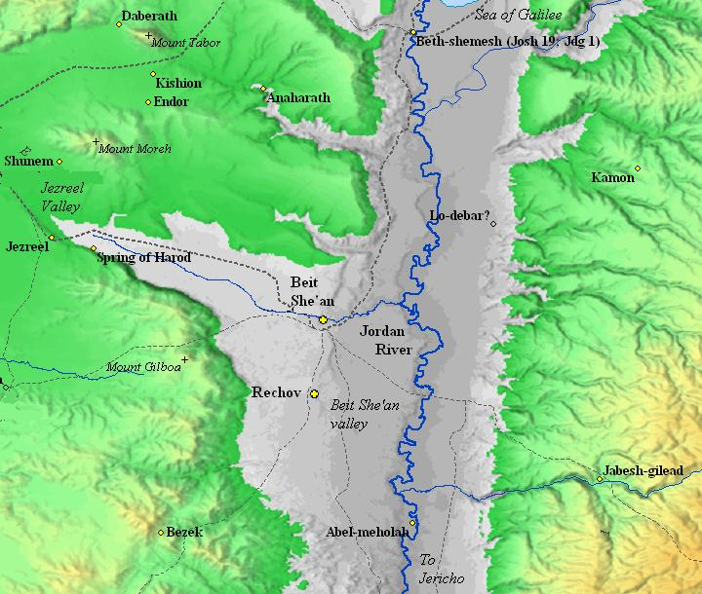
Saul’s Final Battle on Mount Gilboa, circa 1010 B.C.

