APOCALYPSE: A Study of Revelation
Chapter 8-10 The Seven Trumpets

Seven Archangels
(According to tradition: Uriel, Raphael, Raguel, Michael, Sariel, Gabriel, Remiel)

Trumpets 1-4 – Plagues on the Earth

Trumpets 5-6 – Demons and Armies

Interlude: The Little Scroll

APOCALYPSE: A Study of Revelation
Chapter 8-10 The Seven Trumpets

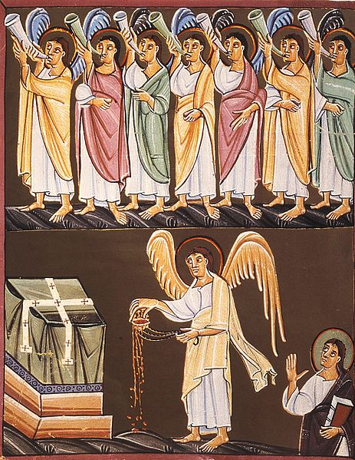
The Seven Trumpets and The Angel with the Censer, German Manuscript of Revelation from ca. 1000 AD

For Further Discussion:
- Why do you think there are parallels between some of the trumpet judgments and the Exodus judgments?
- Do you think Satan is a force behind events in the world today?

Point your camera here to link to the Friday Questions podcast or visit www.SoWeSpeak.com.

