APOCALYPSE: A Study of Revelation
Chapter 3

Letters to the Seven Churches
Ephesus – The Steadfast Church (Apostles – 100AD)

Smyrna – The Persecuted Church (100 – 313 AD)

Pergamum – The Morally Compromising Church (313 – 500 AD, Papacy)

Thyatira – The Doctrinally Compromising Church (500 – 1500 AD, Papal Age)

Sardis – The Counterfeit Church (1517 – 1793 AD, Luther to Wesley)

Philadelphia – The Obedient Church (1793 - ? AD, Great Awakening with Wesley, Whitefield)

Laodicea – The Materialistic Church (Liberal Church in Modern Times)

APOCALYPSE: A Study of Revelation
Chapter 3

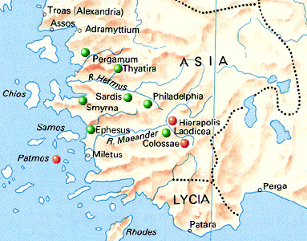

For Further Discussion:
- Which of the challenges of the seven churches seems most like our current challenge?
- What lessons can we learn from Jesus’ attitude toward the churches? His care, his warnings?
- Why does spiritual infidelity to God seem to be linked with sexual immorality toward others?
Point your camera here to link to the Friday Questions podcast or visit www.SoWeSpeak.com.

