APOCALYPSE: A Study of Revelation
Chapter 2

- Interpretive approaches to the book of Revelation: When will these things happen?

  - Preterist View – Visions describe events which happened in the 1st century
  - Historicist View – Visions are a roadmap of history between 1st and 2nd coming of Christ
  - Futurist View – Visions describe events that will happen in a 7-year window in the future
  - Symbolic View – Visions describe recurring events of God’s triumph over evil

- Letters to the Seven Churches
  - Ephesus – The Steadfast Church

  - Smyrna – The Persecuted Church

  - Pergamum – The Morally Compromising Church

APOCALYPSE: A Study of Revelation
Chapter 2

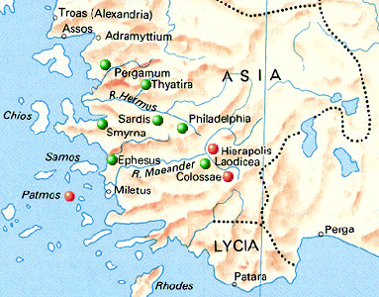

For Further Discussion:
- The Greco-Roman world had many gods. What are some of the gods of our time? What does the worship of the modern gods look like?
- Had you ever considered that persecution might be economic, not just physical?

Point your camera here to link to the Friday Questions podcast or visit www.SoWeSpeak.com.

