APOCALYPSE: A Study of Revelation
Chapters 13: The Number of the Beast

The Beast from the Sea - Antichrist

The Beast from the Earth – False Prophet

The Number of the Beast

For Further Discussion:
- What were you taught growing up, if anything, about the Antichrist?
- Stepping back from the details of Chapter 13, what is your overall impression of the Dragon, Antichrist, and False Prophet? Do the images invoke any feelings?
- Throughout history there has been a tendency to see the Antichrist in the form of various oppressive powers and leaders. Do you think there is validity to this?
- Why do you think the Beast marks his subjects?

APOCALYPSE: A Study of Revelation
Chapters 13: The Number of the Beast

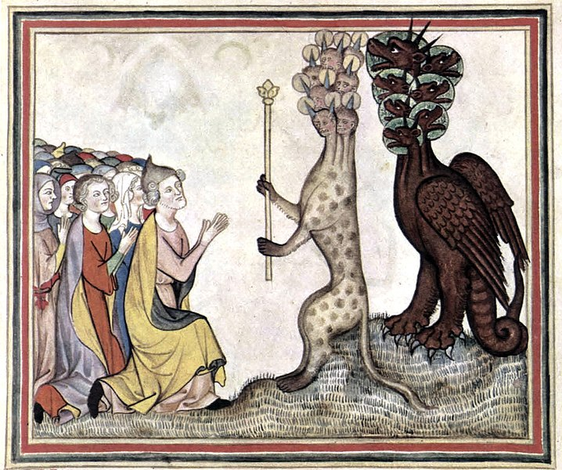
The Dragon and the Beast from the Sea (Antichrist), 1330 A.D.

Point your camera here to link to the Friday Questions podcast or visit www.SoWeSpeak.com.

