APOCALYPSE: A Study of Revelation
Chapter 11: The Two Witnesses

Daniel’s Prophecy of Seventy Weeks (Daniel 9)

Measuring the Temple (Revelation 11)

The Two Witnesses (Revelation 11)

The Seventh Trumpet Sounds

APOCALYPSE: A Study of Revelation
Chapter 11: The Two Witnesses

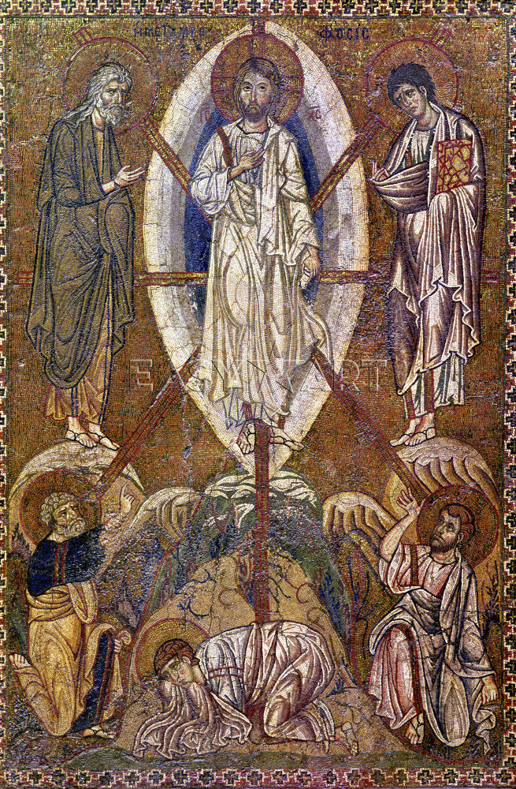
The Transfiguration, Matthew 17

For Further Discussion:
- Why would God send witnesses during the final judgment of earth?
- What is the significance of the world gloating over the dead witnesses and God raising them to heaven?
- Given that we are witnesses to a crumbling world, does this passage encourage you? How so?

Point your camera here to link to the Friday Questions podcast or visit www.SoWeSpeak.com.

