The 400 Year Road
Between the Old and New Testament – Part 4

The Roman Empire

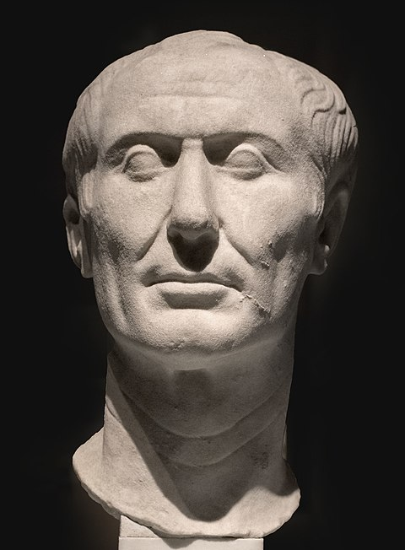
Julius Caesar, 100-44 BC

King Herod

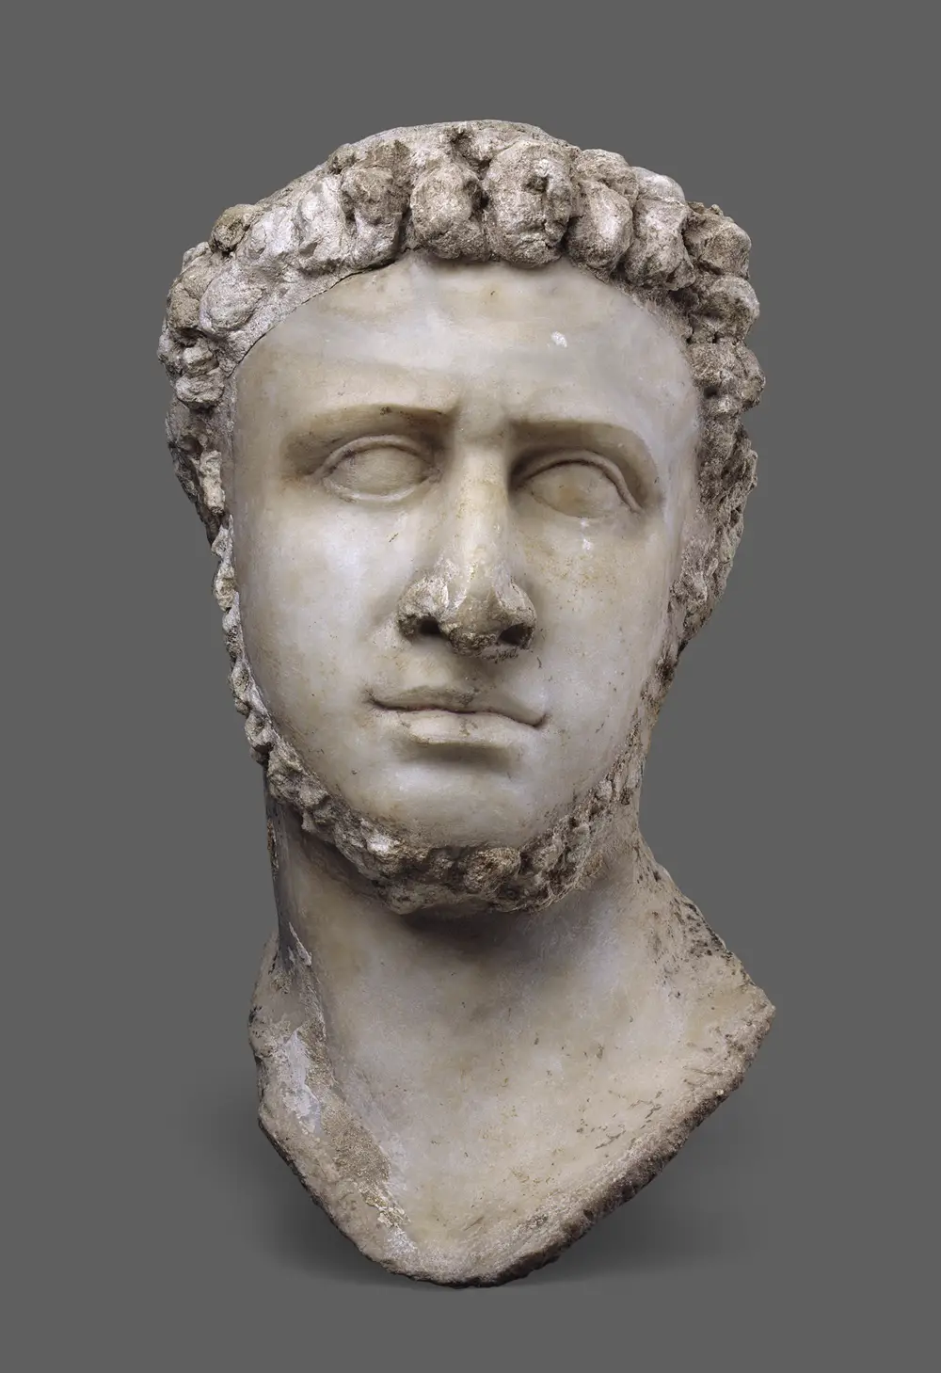
Herod the Great,
72 - ~4 BC

The 400 Year Road
Between the Old and New Testament – Part 4

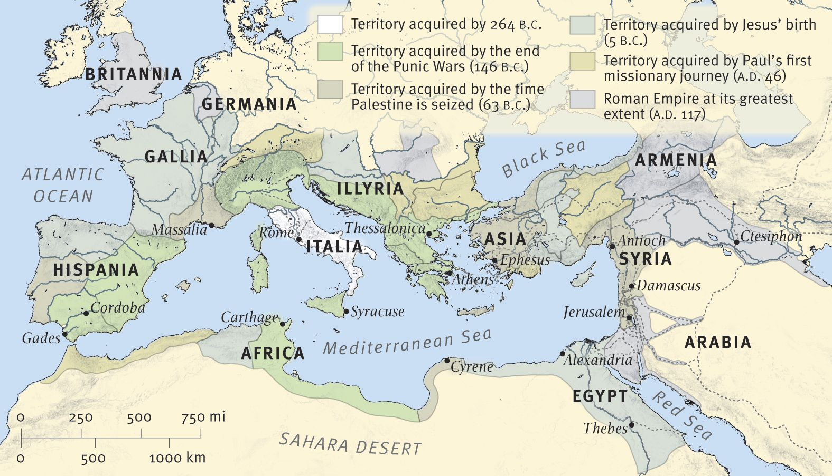
The Roman Empire in New Testament Times

For Further Discussion:
- As you think about the succession of kingdoms leading up to Jesus, how can you see God’s working to set the stage?
- Do you think God is still architecting events for a purpose? Why and at what level of detail do you think he is working in the modern world?
- How do you think God has been and is now working in your life? Do you see signs of his concern for you?

