Living the Christian Life
The Letter to the Thessalonians – Part 4

When Will Jesus Return? (5:1-11)

Darkness and Light

The Purpose of Our Focus on the End Times

For Further Discussion:
- How would you explain the phrase “children of light” in your words?
- In verses 6 and 8 we are told to be “sober” or “self-controlled”. What does it mean to be self-controlled? What is the opposite of self-controlled?
- Why do you think we are not told when Jesus will return? (Hint: 2 Peter 3:8-9)

Living the Christian Life
The Letter to the Thessalonians – Part 4

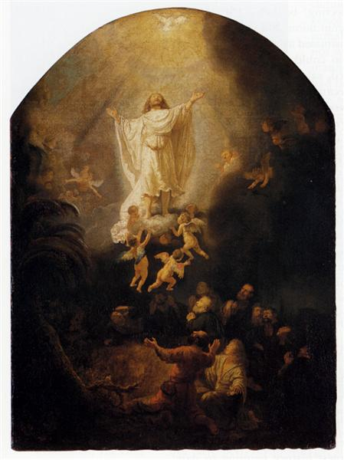
The Ascension of Christ, Rembrandt 1636 A.D.

