Living the Christian Life
The Letter to the Thessalonians – Part 1

Paul, Silas, and Timothy on a Mission Trip – 49 B.C.

The Church in the city of Thessalonica – Acts 17

Paul’s letter to the Thessalonian Christians (1 – 3:13)

Living the Christian Life
The Letter to the Thessalonians – Part 1

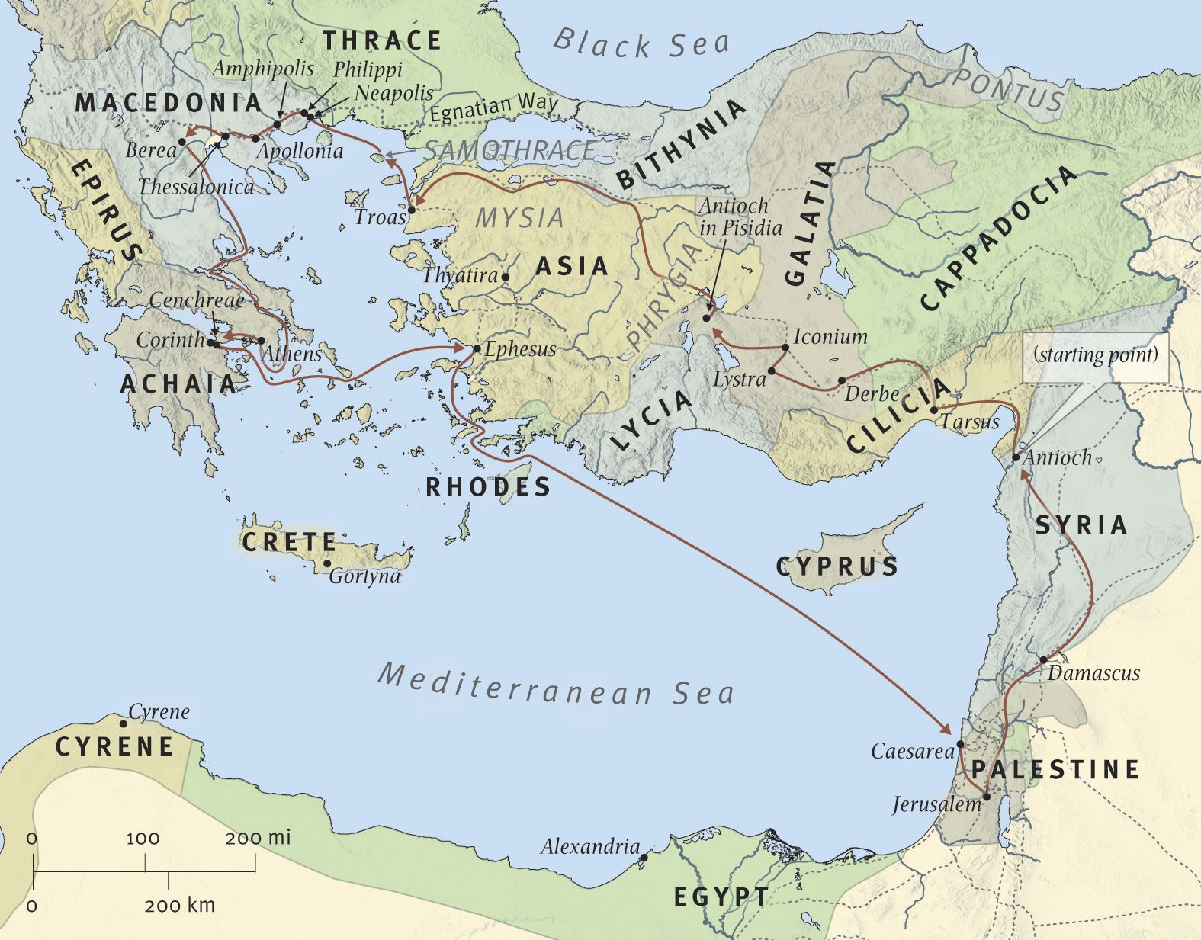Paul, Silas, and Timothy; 2nd Mission Trip; ca. 49-52 AD

For Further Discussion:
- Knowing that the New Testament letters are not only inspired teaching but personal letters to real churches, does that change the way you read them? Do you feel a connection to those people?
- Why do you think a message that was so up front about trials for those who believe would be so compelling to people? What are today’s trials?
- What is it about the Gospel that made you say “Yes” despite the promise of hardship?

